

Microsoft Office 365 Single Sign-On (SSO) with AD FS 2.0
Microsoft France
Published: June 2012
Version: 1.0a
Authors: Philippe Beraud (Microsoft France), Jean-Yves Grasset (Microsoft France)
Contributor: Philippe Maurent (Microsoft Corporation)
Copyright
© 2012 Microsoft Corporation. All rights reserved.
Abstract

Through its support for the WS-Federation (WS-Fed) and WS-Trust protocols, Microsoft Active Directory Federation Services (AD FS) 2.0 provides claims-based (Web) single sign-on (also known as identity federation) with the Microsoft Office 365 offering and its Web application and rich client applications.
Building on existing documentation, this document is intended to provide a better understanding of the different single sign-on deployment options for the services in services in Office 365, how to enable single sign-on using corporate Active Directory credentials and AD FS 2.0 to the service in Office, and the different configuration elements to be aware of for such deployment.
This document is intended for system architects and IT professionals who are interested in understanding the basics of the single sign-on feature of Office 365 with AD FS 2.0 along with planning and deploying such a deployment in their environment.
This document is provided “as-is”. Information and views expressed in this document, including URL and other Internet Web site references, may change without notice. You bear the risk of using it.
Some examples depicted herein are provided for illustration only and are fictitious. No real association or connection is intended or should be inferred.
This document does not provide you with any legal rights to any intellectual property in any Microsoft product. You may copy and use this document for your internal, reference purposes. You may modify this document for your internal, reference purposes.
© 2012 Microsoft Corporation. All rights reserved.
Microsoft, Active Directory, Internet Explorer, SQL Server, Windows, Windows PowerShell, and Windows Server are trademarks of the Microsoft group of companies. All other trademarks are property of their respective owners

Content

1 Introduction 1
1.1 Objectives of this paper 2
1.2 Organization of this paper 4
1.3 About the audience 4
1.4 About the live demo at the MTC Paris/Interop Lab 4
2 A brief overview of Active Directory Federation Services (AD FS) 2.0 6
2.1 A passive/active Security Token Service (STS) 7
2.2 Federation in heterogeneous environments 8
2.3 Terminology used in this paper 10
2.4 Deployment types notes 11
3 Federated authentication in Microsoft Office 365 14
3.1 Requirements for Federated Identities 15
3.2 Sign-in Experience for Federated Identities 19
3.3 Types of authentication for Federated Identities 20
4 Understanding the SSO configuration and related considerations 23
4.1 Preparing for single sign-on 24
4.2 Planning and deploying AD FS 2.0 26
4.3 Installing and configuring the Microsoft Online Services Module 30
4.4 Verifying the single sign-on 41
5 Understanding how federated authentication works in Office 365 43
5.1 Understanding the AD FS 2.0 configuration 43
5.2 Understanding the passive/Web profile authentication flow 58
5.3 Understanding the MEX/rich client profile authentication flow 60
5.4 Understanding the EAS Basic Auth/Active profile authentication flow 61
6 Some information you should be aware of 64
6.1 Supporting Multiple Top Level Domains 64
6.2 Supporting Strong Authentication (2FA) for Office 365 65
6.3 Limiting Access to Office 365 Services Based on the Location of the Client 68
6.4 Using Smart Links for Office 365 71

Introduction
Microsoft Office 365 provides secure anywhere access to professional email, shared calendars, instant messaging (IM), video conferencing, and document collaboration.
It represents the cloud version of the Microsoft communication and collaboration products with the latest version of the Microsoft desktop suite for businesses of all sizes. Office 365 indeed includes:
- Microsoft Office: Microsoft Office Professional Plus 2010 seamlessly connects with Microsoft Office Web Apps for a productivity experience across PCs, mobile devices, and browsers;
Note:
An appropriate device, Internet connection, and supported browser are required. Some mobile functionality requires Office Mobile 2010 which is not included in Office 2010 applications, suites, or Office Web Apps. Furthermore, there are some differences between the features of the Office Web Apps, Office Mobile 2010, and the Office 2010 applications.

- Microsoft Exchange Online: Exchange Online offers cloud-based email, calendar, and contacts with the most current antivirus and anti-spam solutions. It enables access to email on virtually any mobile device and takes advantage of options for voice mail, unified messaging, and archiving;
- Microsoft SharePoint Online: SharePoint Online is a cloud-based service for creating sites that connect colleagues, partners, and customers using enterprise social networking and customization;
- Microsoft Lync Online: Lync Online offers cloud-based IM, presence, and online meeting experiences with screen sharing, voice and video conferencing.
Note:
For additional information on Office 365 in addition to the content of this paper, please refer to the product online documentation, the Office 365 Deployment Guide for Enterprises, the Office 365 Tech Center web site, and the Office 365 Community web site (blogs, forums, wikis, etc.).

With the exception of Internet sites for anonymous access created with SharePoint Online, users must be authenticated when accessing services in Office 365.

Objectives of this paper
Through its single sign-on feature, Office 365 provides organizations with the ability to authenticate against the organization’s Active Directory Domain Services (AD DS), allowing their users to use their corporate credentials to access their services in Office 365 that they have been provisioned for.
Thus, users that are on the internal corporate network or connected through a VPN will have seamless access to services in Office 365. If users are accessing services in Office 365 from home or from any computer not connected to the corporate network, they will also still have access to services in Office 365 using their corporate credentials. Such a user sign-in experience is awaited by many of the organizations:
- Work computer on a corporate network: When users are at work and signed in to the corporate network, single sign-on enables them to access the services in Office 365 without signing in again;
- Roaming with a work computer: For users who are logged on to domain-joined computers with their corporate credentials, but who are not connected to the corporate network (for example, a work computer at home or at a hotel), single sign-on enables them to access the services in Office 365 without signing in again as well;
- Home or public computer: When the user is using a computer that is not joined to the corporate domain, the user must sign in with corporate credentials to access the services in Office 365. This is still an advantage since they will only have to remember one set of credentials for their corporate and Office 365 accesses.
As of writing, this authentication with the single sign-on feature of Office 365 is provided only through the Active Directory Federation Services (AD FS) 2.0 service that the organization deploys on-premise and then configures Office 365 to securely communicate with.

As a short introduction, by leveraging several OASIS standards like:
- WS-Federation (WS-Fed),
- WS-Trust,
- Security Assertion Markup Language (SAML) 2.0,
Microsoft Active Directory Federation Services (AD FS) 2.0 Release to Web (RTW) provides claims-based cross-domain (Web) single sign-on (SSO) (also known as identity federation) with Microsoft and non-Microsoft federation solutions.
Wikipedia defines identity federation as follows:
“Federated identity, or the ‘federation’ of identity, describes the technologies, standards and use-cases which serve to enable the portability of identity information across otherwise autonomous security domains. The ultimate goal of identity federation is to enable users of one domain to securely access data or systems of another domain seamlessly, and without the need for completely redundant user administration.”
Built on existing Microsoft documentation and knowledge base articles, this paper further presents the single sign-on feature (also known as identity federation) of Office 365.
Special thanks to Ross Adams, Microsoft Senior Program Manager, for the provided valuable content on this subject such as the MSDN Channel 9 webcast Microsoft Office 365: Identity
and Access Solutions.
For that purpose, beyond a short depiction of the AD FS 2.0 technology to introduce key concepts, requirements, and components for the rest of the paper, it:
- Describes the different identity options in Office 365;
- Shortly depicts in this context the identity architecture and features in Office 365;
- Describes the various implementation scenarios for federated authentication;
- Describes how federated authentication works with AD FS 2.0;
- Covers additional information you be aware of.
, so that Microsoft Office 365 projects involving AD FS 2.0 in this context can be more easily completed, and consequently enabling customers to realize the full potential of the Microsoft Office 365 offering.
Whilst single sign-on is not required for directory synchronization (but it will provide a richer user experience), directory synchronization is however a requirement for single sign-on.
Hence, the implementation of directory synchronization is needed in order to keep the on-premise AD DS in sync with the Microsoft Online Services Directory. One of the benefits is that it enables controlling and managing the corporate user account in the traditional way through Active Directory Users and Computers. This one piece really does provide seamless user management between the on-premise and Office 365 environments. The Microsoft Online Services Directory Synchronization Tool enables service administrators keeping Office 365 users, contacts, and groups updated with changes made in the on-premise AD DS.
It is recommended to first install and configure single sign-on, and then implement directory synchronization. This is not a hard requirement but it is recommended.
Directory synchronization is not something that is new for Office 365. It is built on top of Microsoft Identity Lifecycle Management (ILM) 2007 (now Microsoft Forefront Identity Manager (FIM) 2010). The configuration of directory synchronization has been simplified for the Office 365 environment. There is no manual configuration that you need to be concerned with, everything being configured via wizards.
Directory synchronization is not further discussed in this document. For details pertaining to this topic, please refer to Active Directory synchronization: Roadmap and Manage directory synchronization in the Office 365 online documentation.

Organization of this paper
To cover the aforementioned objectives, this document adopts an organization according to the following themes, each of them being addressed in the following sections:
- A brief overview of Active Directory Federation Services (AD FS) 2.0;
- Federated authentication in Microsoft Office 365;
- Understanding how federated authentication works in Office 365;
- Understanding the SSO configuration and related considerations;
- Some information you should be aware of;
Finally, references provided in the appendixes enable to easily search the Web for additional information.

About the audience
(Cross-domain) single sign-on − also known as identity federation − in general is a broad topic, with many facets, depths of understanding, protocols, standards, tokens, etc. This paper addresses the single sign-on topic only from the Office 365 perspective and from both conceptual and technical levels.
As of writing, and as previously outlined, AD FS 2.0 is the only supported technology to enable this capability (even if this is something that may evolve in the future).
Note:
For information on the single sign-on feature of Office 365 with AD FS 2.0 in addition to the content of this paper, please refer to the product documentation, the dedicated Single Sign-On FAQ and the Office 365 SSO content map.

This document is intended for system architects and IT professionals who are interested in understanding this capability of Office 365. As an introduction, one can work through the series of Office 365 virtual labs available on to this topic.

About the live demo at the MTC Paris/Interop Lab
 Microsoft Technology Centers (MTC) are collaborative environments that provide access to innovative technologies and world-class expertise, enabling our customers and partners to envision, design, and deploy solutions that meet their needs.
Since 2004, MTC Paris, is part of these global centers designed to provide our customers with an actionable set of steps on how a Microsoft solution can assist them in achieving their key business objectives. Inside this facility, MTC architects and Microsoft technologies Experts, through a discovery process and scenario-based demonstrations running in MTC datacenter, play a critical role in addressing our customers’ challenges.
Interestingly enough, MTC Paris is hosting and running Microsoft France Interop Lab in order to allow customers to see and understand how Microsoft solutions and action can interoperate with other technologies or products around several topics such as : advanced Web services, PHP, Java, SAP, application lifecycle management and last but not least security & identity.
In this lab, customers and partners test multi-vendor technical configurations in order to adapt solutions to their needs in terms of operational interoperability. MTC Paris hosts more than 20 competing players’ solutions. These solutions are deployed on MTC Paris datacenter infrastructure which is built upon more than 300 servers and 200 terabytes storage. Working with many competing publishers, we facilitate the integration of heterogeneous systems. Thus interoperability becomes a guarantee of integration for our customers and enables them to create value by maximizing the investment in innovation.
In order to ensure both identity portability and security in a loosely coupled environment, it is fundamental to master the identity management part in each involved security realm for the considered scenario. As aforementioned, the Microsoft platform natively offers a series of products and technologies to sustain the notion of claim-based identity: ready to use enterprise-class Claims Provider Security Token Service (STS), Framework for building claims-aware applications and services (including authentication, access control, auditing, etc.), etc. In “real world” heterogeneous environments, these components haven’t no choice rather than being truly interoperable.
To illustrate this interoperability, the MTC Paris Security and Identity Management Interop Lab proposes a permanent dedicated platform offering multiple identity management scenarios, and more especially the one describes in this paper, i.e. the federated collaboration scenario by using the OASIS WS-Trust and WS-Federation protocols, Microsoft AD FS 2.0 for identity solutions and Microsoft Office 365 solutions for the exposed collaboration resources in the Cloud.

A brief overview of Active Directory Federation Services (AD FS) 2.0
Beginning with the Windows 2000 (Server) platform, the Kerberos-based user identity provided by AD DS has facilitated secure authorization and single sign-on to Active Directory-aware (Microsoft and non-Microsoft) resources located inside its own and other trusted Active Directory domains/forests.
AD FS 2.0 enables identity federation, extending the notion of above centralized authentication, authorization, and single sign-on to Web applications and services located virtually anywhere.
As previously introduced, identity federation relies on standards-based protocols to establish federation trusts between claims providers and relying parties, facilitating secure access to Web applications and services across security boundaries.
For an organization, AD FS 2.0 provides corporate users with a rich federated experience and seamless access to resources located:
- Inside the corporate intranet;
- Outside the corporate network in a corporate perimeter network, extranet and/or in the Cloud, for example in the Microsoft Windows Azure platform, the Microsoft’s Platform as a Service (PaaS) offering;
- At the perimeter networks of partner organizations that have made resources available to the considered organization’s users;
- In the Cloud with Software as a Service (SaaS) vendors that support federated identity, for example, Microsoft with its Microsoft Office 365 offerings in the context of this paper.
AD FS 2.0 is a component of the Windows (Server) platform and, as such, the right to use it is included in the associated license costs.
Important note:
The AD FS role available in Windows Server 2008 (R2) doesn’t correspond to AD FS 2.0; this is the previous version 1.1 instead. The AD FS 2.0 software package for your specific operating system version (either Windows Server 2008 or Windows Server 2008 R2) is the AdfsSetup.exe setup file. To download this file, go to Active Directory Federation Services 2.0 RTW.

Important note:
As of writing, update rollup 2 for AD FS 2.0 is available. This update rollup (or the previous one) includes hotfixes and updates for AD FS 2.0 RTW that are of special interest in the context of this paper for the single sign-on feature of Office 365. For more information about this update rollup and its download, please see article 2681584 Description of Update Rollup 2 for Active Directory Federation Services (AD FS) 2.0.

A passive/active Security Token Service (STS)
AD FS 2.0 is fundamentally a Security Token Service (STS). Such a service is able to issue, validate and exchange security tokens.
Security tokens consist of a collection of claims, which are statements made about users, for example name, id, email, group, role, privilege, or capability, used for authentication and authorization decision purposes.
Security tokens typically follow a secure, standardized method of packaging claims for transport from a claims provider, i.e. a trusted federation partner that issues the token, to a relying party, i.e. a trusting federation partner that understands and consumes the token.
The Security Assertion Markup Language (SAML) standard developed by OASIS Security Services (SAML) Technical Committee (TC), from whom Microsoft Corporation is a TC participant, describes such security token format: the SAML format. Office 365 supports SAML 1.1 assertion/token.
A STS can issue tokens in various formats and can protect the content of security tokens in transit via the use of X.509 certificate(s) for token signing, which makes it possible for a relying party to notably validate trusted claims providers. (Token encryption is also supported.)
The concept of exchange induces the processing and transforming capability of tokens in terms of type of trust, token format, semantics and (values of) claims for “impedance adaptation”.
In order to serve and process related claim requests, AD FS 2.0 includes a claims pipeline, which represents the path that claims must follow through the STS before they can be issued as part of a security token. The STS manages the entire end-to-end process of flowing claims through the various stages of the claims pipeline, which also includes the processing of claim rules by the claim rule-based engine.
For that purpose, AD FS uses AD DS as a credential store. AD FS 2.0 can also use attributes coming from several attribute stores, such as Active Directory Lightweight Directory Services (AD LDS), Microsoft SQL Server databases, and other data sources.
We recommend reading the article Understanding Key Concepts Before You Deploy AD FS 2.0 as a good introduction to AD FS 2.0.
AD FS 2.0 can consequently play the following roles (and participate accordingly in several types of trust schema’s topologies):
- A pure Identity Provider Security Token Service (IP-STS): This is when AD FS 2.0 has no configured Claim Providers, except a credential store and optional attribute store(s).
The authentication is performed by the IP-STS against the credential store and a security token is issued to the target relying party so that access control decisions can be made or derived on that basis;
- A pure Relying Party STS (RP-STS): This is when AD FS 2.0 has configured Claims Providers, but all local authentication methods are disabled in the configuration. AD FS 2.0 can only direct the user to authenticate with a trusted Claims Provider/STS.
The RP-STS checks the security token presented by the requestors and generates in turn a security token to the target resource or the next relying party in the chain to the target resource. In the former case, it can issue a delegation token (Act As tokens) in order to support delegation scenarios;
- Hybrid: This is when AD FS 2.0 has configured Claims Providers, and uses a local authentication method enabled in the configuration.

Federation in heterogeneous environments
To adapt to an open set of federation scenarios, AD FS 2.0 supports multiple OASIS standards widely implemented and used in the enterprise space: WS-Federation, WS-Trust, SAML 2.0, etc.
Indeed, similar to the previous version 1.1, AD FS 2.0 supports the WS-Fed Passive protocol for browser-based passive clients. This specification uses the SAML assertion format for security tokens, but as its name suggest, not the protocol.
This protocol is adopted by most 3rd party IDA vendors. Consequently, having AD FS 2.0 supporting WS-Fed Passive protocol potentially allows interoperability with major market solutions. As later depicted, this protocol is used for the single sign-on feature in Office 365.
AD FS 2.0 adds to this the support the Security Assertion Markup Language (SAML) 2.0 protocol along with the support for SAML 1.1 and 2.0 assertions (security tokens). The white paper Using AD FS 2.0 for interoperable SAML 2.0-based federated Web Single Sign-On provides a better understanding of the different configuration elements to take into account when using AD FS 2.0 for interoperable SAML 2.0-based federated Web single sign-on.
As of this paper, the SAML protocol (SAML-P) isn’t supported by the single sign-on feature of Office 365.
Note:
The SAML specification set defines XML-based assertions, protocols, bindings, profiles, etc. The SAML core specification refers to the general syntax and semantics of SAML assertions as well as the protocol used to request and transmit those assertions from one system entity to another. SAML assertions are usually transferred from a Claims Provider to a Relying Party. Whilst the single sign-on feature in Office 365 doesn’t currently support the SAML 2.0 protocol (SAML-P 2.0), it uses for the authentication token the SAML 1.1 assertions as specified in the SAML 1.1 core specification.

Note:
SAML-P 2.0 may be introduced later for the single sign-on feature in Office 365 with a limited application support.

Furthermore, AD FS 2.0 natively offers the ability of a protocol gateway by acting as a gateway between SAML 2.0 and WS-Fed Passive protocols for front-channel federation. The white paper Step-by-Step Guide: Federated Collaboration with Shibboleth 2.0 and SharePoint 2010 technologies fully illustrates this capability in the context of SharePoint 2010.

AD FS 2.0 successfully passed the SAML 2.0 interoperability tests for these modes as described in the document Liberty Interoperability Testing Procedures for SAML 2.0 version 3.2.2 .
This capability of AD FS 2.0 is a consequence of the major announcement that was made by Microsoft on February 2008 about the enhancements of its products openness, interoperability, and the creation of new opportunities for developers, partners, customers and competitors.
Exchanging information between people and organizations, interoperability between applications and services have become first-class needs. Microsoft committed to interoperability a while ago, after having exchanging with their customers about their interoperability needs and listening to them on how Microsoft products should become even more open and interoperable.
In order to fulfill those stakes and needs, Microsoft applies four interoperability principles to their own broadly used products like Windows Server, SharePoint, etc. from now on:
- Guarantee an open connection to these products;
- Promote data portability;
- Enhance industry standards support;
- Favor exchange and collaboration in the IT industry including with the Open Source communities about interoperability and standards topics.
Of course, these principles apply to AD FS 2.0 which clearly has such goals.
Beyond mostly browser-based protocols like the WS-Fed Passive and SAML 2.0 protocols, AD FS 2.0 also supports for smart clients the OASIS WS-Trust standard, which is also leveraged by the single sign-on feature in Office 365.
All these capacities are recognized by the market. Indeed, on the occasion of the European Identity Conference (EIC) 2009, the leading European event for Identity and Access Management (IAM) and GRC (Governance, Risk Management, and Compliance), the analyst firm Kuppinger Cole conferred the European Identity Award 2009, in the category “Best innovation”, to Microsoft for the Geneva project (AD FS 2.0 & WIF 1.0), in which federation becomes part of user containers, “one of the most significant enhancements for future use and dissemination of the Identity Federation”.

Terminology used in this paper
Throughout the rest of this document, the following terms detailed in Table are used regarding AD FS 2.0.
Table : AD FS 2.0 Terminology
Term |  | Description
AD FS 2.0 configuration database | A database used to store all configuration data that represents a single AD FS 2.0 instance or federation service. This configuration data can be stored either using the Windows Internal Database (WID) feature included with Windows Server 2008 (R2) or using a Microsoft SQL Server database.
Claim | A statement that one entity makes about itself or another subject. For example, the statement can be about a name, email, group, privilege, or capability. Claims have a provider that issues them (in this context, an Office 365 customer) and they are given one or more values. They are also defined by a claim value type and, possibly, associated metadata.
Federation service | A logical instance of AD FS 2.0. A federation service can be deployed as a standalone federation server (FS) or as a load-balanced federation server farm. The name of the Federation Service defaults to the subject name of the SSL/TLS certificate. The DNS name of the Federation Service must be used in the Subject name of the SSL/TLS certificate.
Federation server | A computer running Windows Server 2008 (R2) that has been configured to act in the federation server (FS) role for AD FS 2.0. A federation server serves as part of a Federation Service that can issue, manage, and validate requests for security tokens and identity management. Security tokens consist of a collection of claims, such as a user's name or role.
Federation server farm | Two or more federation servers in the same network that are configured to act as one Federation Service instance.
Federation server proxy | A computer running Windows Server 2008 (R2) that has been configured to act as an intermediary proxy service between a client on the Internet and a federation service that is located behind a firewall on a corporate network. In order to allow remote access to the services in Office 365, such as from a smart phone, home computer, or Internet kiosk, you need to deploy a federation server proxy (FS-P).
Relying party | An AD FS 2.0 federation service, a third-party federation solution, an application or a service that consumes claims in a particular transaction.
Relying party trust | In the AD FS 2.0 Management snap-in, a relying party trust is a trust object that is created to maintain the relationship with another Federation Service, application, or service (in this case Office 365) that consumes claims from your organization’s Federation Service.
Network load balancer | A dedicated application (such as Network Load Balancing) or hardware device (such as a multilayer switch) used to provide fault tolerance, high availability, and load balancing across multiple nodes. For AD FS 2.0, the cluster DNS name that you create using this NLB must match the Federation Service name that you specified when you deployed your first federation server in your farm.

Note:
For additional information on AD FS 2.0 in addition to the content of this paper, please refer to the product documentation, and the dedicated AD FS 2.0 Q&A forum.

Deployment types notes

Software prerequisites and requirements
In order to setup a federation server, Microsoft Active Directory Federation Services (AD FS) 2.0 Release to Web (RTW) requires Windows Server 2008 Service Pack 2 (SP2) or Windows Server 2008 R2 in terms of Windows Server Operating System.
Note:
As already noticed, there is a Server Role on Windows Server 2008 and Windows Server 2008 R2 for AD FS to be installed. This not the correct version; the version is 1.1 whereas 2.0 is required for the single sign-on feature of Office 365.

The following software prerequisites are also needed for AD FS 2.0 RTW:
- Internet Information Services (IIS) 7 or 7.5 depending on the Windows Server version;
- Microsoft .NET Framework 3.5 SP1.
For further details on system requirements, please refer to the AD FS 2.0 home page.
You must install AD FS 2.0 hotfixes after installing AD FS 2.0. As previously mentioned, an Update Rollup 2 for AD FS 2.0 is available. This Update Rollup includes hotfixes and updates for AD FS 2.0 RTW that are of special interest in the context of this paper for the single sign-on feature of Office 365.

Federation service
As suggested by the above terminology, there are two deployment types for AD FS 2.0 federation servers: stand-alone and farm.
A stand-alone federation server is a single instance of the federation service. You typically create a stand-alone federation server when your production environment is small or if you are evaluating the AD FS 2.0 technology.
A (load-balanced) federation server farm contains multiple federation servers, which host the same instance of a federation service. Conversely, you typically create a farm when you require high availability and load balancing. Creating a new federation service for a farm scenario will cause the first computer in the farm to be the primary federation server for the farm.

Storage of Configuration Information
In AD FS 2.0, configuration information is stored in a database. A stand-alone federation server stores its configuration information locally in the Windows Internal Database (WID).
WID does not need to be installed manually; it is installed by the first application or service that requires it. WID runs in its own Windows service and is included with Windows Server 2008 and Windows Server 2008 R2. WID is a variant of SQL Server Express and is meant for on-box applications or services which need a SQL backend.
The WID database is read/write in a stand-alone federation server whereas in (load-balanced) federation server farm scenarios, the database is read/write on the primary federation server and read-only on all secondary federation servers in the farm. Secondary federation servers connect to and synchronize the data with the primary federation server in the farm by polling it at regular intervals to check whether data has changed. The secondary federation servers exist to provide fault tolerance for the primary federation server while acting to load-balance access requests.
Configuration information can alternatively be stored in a SQL Server database, which provides additional capabilities, like additional performance enhancements (including the ability to scale out using more than 5 federation servers, which is the limit for WID per farm), SAML token replay detection and SAML artifact resolution. For additional information, please refer to the article Federation Server Farm Using SQL Server.

Proxies

AD FS 2.0 federation server proxy
The federation server proxy role can be deployed in the perimeter network to enhance the security and performance of the AD FS 2.0 installation by providing the following benefits:
- Security: the federation server proxy provides an additional layer of defense by isolating front-end requests from the corresponding back-end requests to the protected federation service, whether it is a stand-alone federation server or a (load-balanced) federation server farm. The federation server proxy processes only the requests that are sent to known HTTP prefixes. It can also provide additional value by validating data in requests (for example, validating certificates) on behalf of AD FS 2.0;
- Key protection: the private token-signing key and service identity key for AD FS 2.0 are not stored on the federation server proxy;
- Corporate resources: the federation server proxy can service AD FS 2.0 client requests without requiring access to corporate resources, such as Active Directory;
- Caching: The federation server proxy can potentially offload the federation server by caching static HTTP content.
Another added benefit of using a federation server proxy is that your external non-domain joined users will see a Forms Based Authentication page instead of the standard authentication prompt.
Similarly to the federation server role, the federation server proxy role can be deployed as a stand-alone federation server proxy or as a (load-balanced) federation server proxy farm.

Alternative proxies
A proxy such as Microsoft Threat Management Gateway (TMG) that can expose/publish the AD FS 2.0 federation service endpoints (see section § 5.1.5 Endpoints) from the perimeter network on to the Internet. For additional information, you can refer to the blog post Publishing ADFS through ISA or TMG Server.
(There is also the ability to implement AD FS 2.0 from a Microsoft Forefront Unified Application Gateway (UAG) Service Pack 1 (SP1) appliance. A description of configuring UAG SP1 for AD FS 2.0 is provided in the article Deploying federation with AD FS of the UAG documentation.)

Federated authentication in Microsoft Office 365
The option to configure AD FS 2.0 is up to each individual company and knowing the expected behavior and experience that you will get is important. With the exception of Internet sites for anonymous access created with SharePoint Online, users must be authenticated when accessing services in Office 365.
For that purpose, the Microsoft Office 365 offers two types of identities:
- Microsoft Online Services cloud IDs (Cloud Identity): Users receive, for signing into services in Office 365, cloud credentials that are separate from other desktop or corporate on-premise credentials. The Cloud Identities are mastered in the service/cloud.

Note:
With the optional directory synchronization, the user IDs mastered on premise can be synchronized to the service/cloud in the form of Cloud Identities.

- Federated IDs (Federated Identity): In companies with on-premise Active Directory, the aforementioned single sign-on feature can be leveraged. Users can then sign into services in Office 365 using their own Active Directory corporate credentials. The user’s IDs are mastered on premise in Active Directory and synchronized to the service in the form of Federated Identities.
Users can gain access to Office 365 by authenticating to their Office 365 user accounts, either through a prompt to provide valid credentials or through a single sign-on process. Once authenticated, users’ identities refer to the user names associated with the Office 365 accounts. Considering the above, we have three authentication types available:
- Cloud Identities;
- Cloud Identities + Directory Synchronization ( DirSync);
- Federated Identities + Directory Synchronization (DirSync).
The above type of identity (cloud vs. federated) affects the user experience, administrative requirements, deployment considerations, and capabilities using Office 365.
The following is the simplified breakdown of the experience:
- User Experience with Cloud Identities: users sign in with their cloud identity. Cloud Identities are authenticated using traditional challenge/response, where users type in their user name and password. Authentication happens in the cloud. Users are always prompted for credentials.
As mentioned above, users have two IDs, i.e. one to access on-premise services and one for the services in Office 365, i.e. the Microsoft Online Services cloud ID. Consequently, users are prompted for credentials even when logged into their AD domain when accessing Office 365 Services. This can actually be mitigated by selecting the save password option when you are prompted in many cases.
- User Experience with Federated Identities: users sign in with corporate ID for access to online and corporate services. In other words, they are authenticated transparently using AD FS 2.0 when accessing Office 365 Services. Authentication happens on premises against the organization’s Active Directory and users get true SSO. Furthermore, 2 Factor Authentication (2FA) can be utilized if it is deployed on-premise.
- Administrator Experience with Cloud Identities: organization’s administrators manage the password policy both in cloud and on premises. The Cloud Identities password policy is stored in the cloud with the Office 365 service. Password reset has to be managed for on premises and Microsoft Online Services cloud IDs and hence the users have to change the password as per the policy for both. Finally, there is no 2FA integration.
- Administrator Experience with Federated Identities: Organization’s administrators manage the password policy on premise only and hence do not need to separately worry about password reset for Federated Identities. The organization’s Active Directory stores and controls the password policy. Password reset occurs for on premise IDs only. Eventually, several 2FA integration options are offered (see section § 6.2 Supporting Strong Authentication (2FA) for Office 365).
Figure Office 365 Identity Platform
The rest of this document discusses the single sign-on feature and the Federated Identities in this context. Consequently, for specific information on Office 365 Cloud Identities such as user account creation, password policy, etc., please refer to the paper entitled Office 365 Identity Service Description as a starting point.

Requirements for Federated Identities

Active Directory requirements
For an organization to leverage the single sign-on feature of Office 365, the domain controllers must run at least Windows Server 2003 or higher with a functional level of mixed or native mode.

Work computer requirements
The work computers must be on the latest Service Packs of Windows XP, Windows Vista or Windows 7. Furthermore, to ensure proper discovery and authentication of services in Office 365, a set of components and updates must be applied to each work computer that uses rich clients (such as Office Professional Plus 2010) and connects to Office 365.
Rather than manually installing the updates, one by one, Microsoft provides an automated setup package, i.e. the Office 365 Desktop Setup application, which automatically configures workstations with the required updates. This application replaces the Microsoft Online Services Connector. If work computers have the Office 365 Desktop Setup application installed, all the requirements for the operating system are met.
The Office 365 Desktop Setup application provides multiple benefits, including:
- Automatically detecting necessary updates;
- Installing updates and components upon approval or silently from a command line;
- Automatically configuring Internet Explorer and Lync for use with Office 365.
Note:
A list of these update requirements is published for organizations that want to use an alternative method of deploying the updates. The article Manually install Office 365 desktop updates fully described the list of required updates.

The Office 365 Desktop Setup application is available for download from the Microsoft Online Portal (MOP). For web-based clients such as SharePoint Online, Outlook Web App (OWA), etc. there is no need to install the Office 365 Desktop Setup application; this is strictly for thick clients such as Outlook and Lync.
One of the key features of the Office 365 Desktop Setup application is the Microsoft Online Services Sign-in Assistant (MOS SIA). This is not the only purpose of the Office 365 Desktop Setup application but it is an important feature in the specific context of this paper.
Note:
The download Microsoft Online Services Sign-In Assistant for IT Professionals RTW (msoidcli_32bit.msi for 32-bit system or msoidcli_64bit.msi for 64-bit system) is intended for IT Professionals, for distribution to managed client systems as part of an Office 365 client deployment, via System Center Configuration Manager (SCCM) or similar software distribution systems. For users who are installing Office 365 by means of the Office 365 Desktop Setup application, this download is not necessary, because the MOS SIA is installed as part of the Desktop Setup process as mentioned above.

As depicted in the community article Description of Microsoft Online Services Sign-In Assistant (MOS SIA), the components of MOS SIA consist of a set of dynamic link library files (DLLs) and a Windows service. These components are called by desktop applications like Office Subscription and Lync to authenticate users to Office 365, and thus to perform authentication token request. This occurs via AD FS 2.0 in the background.
The architectural relationship between the components is as follows.
Figure Microsoft Online Services Sign-In Assistant Architectural overview
Note:
The Windows Security Support Provider Interface (SSPI) is a software interface with a well-defined common API for obtaining integrated security services for authentication (as well as message integrity, message privacy, and security quality of service) for any distributed application protocol. One or more software modules provide the actual authentication capabilities. Each module, called a security support provider (SSP), is implemented as a dynamic link library (DLL). An SSP provides one or more security packages. A variety of SSPs and packages are available. Windows ships with the NTLM security package and the Microsoft Kerberos protocol security package. In addition, you may choose to install the Secure Socket Layer (SSL) security package, or any other SSPI-compatible SSP.
For additional information on SSPI, please refer to the Microsoft TechNet article The Security Support Provider Interface and the Microsoft MSDN article Security Support Provider Interface (SSPI).

The following binaries are installed in the %Program Files%\Common Files\Microsoft Shared\Microsoft Online Services location.
- MSOIDCLI.dll: A file that can be loaded directly by applications that needs to authenticate users to Office 365;
- MSOIDSVC.exe: Installed as a Windows service with the service name MSOIDSVC. This is the core component that executes the actual logons and service ticket requests to the on-premise AD FS 2.0 federation service and the sign-in service of the Office 365 Identity Platform;
- MSOIDSVCM.exe: A watchdog process that monitors the MSOIDSVC service. It is launched when the MSOIDSVC service is started;
- MSOIDRES.dll: A resource file that contains localized text strings for error messages.
The following additional DLLs are installed on a Windows 7 system:
- MSOIDCredProv.dll: This is the Windows Credential Provider component that is registered as a COM object in the system;
- MSOIDSSP.dll: This is the SSP component that is installed in the %windir%\system32 folder.
Note:
On 64-bit versions of Windows, msoidcli.dll and msoidres.dll are installed in the %Program Files (x86)%\Common Files\Microsoft Shared\Microsoft Online Services location. On 64-bit versions of Windows 7, msoidcredprov.dll is also installed in this folder.

The following registry keys and values are created or updated as part of the installation of MOS SIA.
Note:
The data of some values is dependent on installed version and language.

[HKEY_LOCAL_MACHINE\SOFTWARE\Microsoft\MSOIdentityCRL]
"Language" (default: dword:00000409)
"TargetDir" (default: %Program Files%\Common Files\Microsoft Shared\Microsoft Online Services)
"MSOIDCRLVersion" (as of writing, current version is 7.250.4287.0)

[HKEY_LOCAL_MACHINE\SOFTWARE\Microsoft\MSOIdentityCRL\Environment]

[HKEY_LOCAL_MACHINE\SOFTWARE\Microsoft\MSOIdentityCRL\Environment\Production]
"RemoteFile" (default: http://clientconfig.microsoftonline-p.net/PPCRLconfig.srf)

[HKEY_LOCAL_MACHINE\SOFTWARE\Microsoft\MSOIdentityCRL\Trace]
"Flags" (default: dword:00000001)
"Level" (default: dword:00000002)

Although the MOS SIA comes with the Office 365 desktop, the Office 365 desktop setup is not an authentication or sign-in service and should not be confused with single sign-on. For more information about the Office 365 desktop setup, see the Office 365 online help topic Set up your desktop for Office 365.

AD FS 2.0 federation server requirements
It should be noted that the Office 365 Desktop Setup application should be installed on all machines that will connect to Office 365 and that includes the machines for the AD FS 2.0 federation service. This is needed on the federation servers by the Microsoft Online Services Module for Windows PowerShell tool so that a connection to the Office 365 environment can be established with Windows PowerShell to federate the domain.
Note:
Windows PowerShell is a command-line shell and scripting language that is designed for system administration and Automation. It uses administrative tasks called cmdlets. Each cmdlet has required and optional arguments, called parameters, that identify which objects to act on or control how the cmdlet performs its task. You can combine cmdlets in scripts to perform complex functions that give you more control and help you automate the administration of Windows and applications. It has become a common way to manage the latest generation of Microsoft Server products on-premise and in the Cloud.
For more information about Windows PowerShell 2.0, please see the Windows PowerShell Web site, the Windows PowerShell online help, and the Windows PowerShell Weblog Windows PowerShell Software Development Kit (SDK) that includes a programmer’s guide along with a full reference.

More precisely, the Microsoft Online Services Module has a dependency on the Microsoft Online Services sign-in assistant (MSO SIA) that comes with the Office 365 Desktop Setup application.
To install the Office 365 Desktop Setup application on an AD FS 2.0 federation server, the operation is identical to the client installation steps.

Sign-in Experience for Federated Identities
The sign-in experience changes depending on the type of Office 365 identity in use. The end-user sign-in experience varies depending on the client types, the access methods, i.e. inside or outside the corporate network, and whether the machine has joined the domain or not.
Table discusses the key combinations for domain joined machine and helps explaining the resulting experiences.
Table : Federated Identity Sign-in experience with Office 365 with a domain joined machine
Application | Inside the corporate network | Outside the corporate network
Outlook 2010/Outlook 2007, Exchange ActiveSync, POP, IMAP | Prompted for credentials on first connection (and at each password change) with checkbox to remember them.
Microsoft Online Portal, SharePoint Online, Office Web Apps | Pop up offers click to sign in with no credentials required¹ | Pop up offers click to sign in and prompted for credentials¹
Outlook Web Apps | Seamless sign on with no prompts | Prompted for credentials
Office 2010/Office 2007 applications with SharePoint Online | Pop up offers click to sign in with no credentials required
Lync 2010 with Lync Online | Seamless sign on with no prompts
¹ All apps require you to enter your username or click to sign in. This can be bypass by using Smart Links (see section § 6.4 Using Smart Links for Office 365).
As per the table above, when using Federated Identities, end-users will not be prompted to enter their passwords on domain-joined machines in many cases:
- When accessing the Microsoft Online Portal (MOP), SharePoint Online, or Outlook Web Apps (OWA) through a browser, inside the corporate network;
- When using Office 2007 or 2010 applications to access SharePoint Online resources;
- When using Lync 2010 to access Lync Online.
Outlook users will be prompted to enter their corporate credentials on first use, at which time they can choose to save their password for future use. In this case, end-users will not be prompted again until they change their password, which depends on the organization’s password policies.
Table discusses the key combinations for non-domain joined machine and helps explaining the resulting experiences.
Table : Federated Identity Sign-in experience with Office 365 without a domain joined machine
Application | Inside the corporate network | Outside the corporate network
Outlook 2010/Outlook 2007, Exchange ActiveSync, POP, IMAP | Prompted for credentials on first connection (and at each password change) with checkbox to remember them.
Microsoft Online Portal, SharePoint Online, Office Web Apps | Pop up offers click to sign in and prompted for credentials¹
Outlook Web Apps | Prompted for credentials
Office 2010/Office 2007 applications with SharePoint Online | Pop up offers click to sign in and prompted for credentials
Lync 2010 with Lync Online | Prompted for credentials
¹ All apps require you to enter your username or click to sign in. This can be bypass by using Smart Links (see section § 6.4 Using Smart Links for Office 365).

Types of authentication for Federated Identities
This section discusses the types of user authentication that work with Office 365 for a Federated Identity.

Authenticating from a Web Browser
As previously mentioned, Office 365 offers several services that you can access using a web browser, including the Microsoft Online Portal (MOP), SharePoint Online, and Outlook Web App (OWA). When you access these services, your browser is redirected to a sign-in page where you provide your sign-in credentials.
The sign-in experience is as follows for a Federated Identity:
- The web browser is redirected to the Office 365 sign-in service, where you type your corporate ID in the form a User Principal Name (UPN) formatted per IETF standard RFC 822 Standard for ARPA Internet Text Messages, for example, johndoe@idmgt.com. The sign-in service determines that you are part of a federated domain and offers to redirect you to the on-premise AD FS 2.0 service for authentication.
- If you are logged on to the computer (domain joined), you are authenticated using Integrated Windows Authentication (Kerberos or NTLMv2) and AD FS 2.0 generates a SAML 1.1 logon token, which the web browser posts to the Office 365 sign-in service. Using the logon token, the sign-in service generates an authentication token that the Web browser posts to the requested service and logs you in.
If your computers have Extended Authentication Protection (EAP), and you use Firefox, Chrome, or Safari, you may not be able to sign in to Office 365 using Integrated Windows Authentication (IWA) from within the corporate network. If this situation occurs, your users might receive logon prompts on a regular basis as described in the article You are repeatedly prompted for credentials when you try to log in the AD FS 2.0 service endpoint in Office 365. This is due to the default configuration (on Windows 7 and patched client operating systems) for AD FS 2.0 and EAP.
Until Firefox, Chrome, and Safari support the EAP feature, the recommended option is for all clients accessing services in Office 365 to install and use Windows Internet Explorer 8 and above. If you want to use single sign-on for Office 365 with Firefox, Chrome, or Safari, you can consider the following approaches that may imply security concerns:
- Uninstalling the Extended Protection for Authentication patches from the computers.
- Changing the Extended Protection for Authentication setting on the AD FS 2.0 server via the Set-ADFSProperties cmdlet:

PS C:\Windows\system32> Add-PSSnapin Microsoft.Adfs.Powershell
PS C:\Windows\system32> Set-ADFSProperties –ExtendedProtectionTokenCheck:None

Note:
For more information, see the AD FS 2.0 Administration with Windows PowerShell section of the AD FS 2.0 Operations Guide and the AD FS 2.0 Cmdlets Reference .

- Reconfiguring the authentication settings for the AD FS 2.0 webpage on each federation server from Integrated Windows Authentication (IWA) to using Forms Based Authentication (FBA) as described in the article Authentication Handler Overview.

Authenticating from Rich Client Applications
Rich clients include Microsoft Office desktop applications that are typically installed on a PC. Authentication from these types of applications can occur in two ways:
- Microsoft Online Services Sign-In Assistant (MOS SIA): The Microsoft Online Services Sign-In Assistant (notably installed by the Office 365 Desktop Setup application) contains the Windows service MSOIDSVC.exe that obtains an authentication token from the Office 365 sign-in service and returns it to the rich client.
With a Federated Identity, and as later depicted in this paper (see section § 5.3 Understanding the MEX/rich client profile authentication flow), the MSOIDSVC service first contacts the AD FS 2.0 federation service to authenticate the credentials (using Kerberos or NTLMv2) and obtain a logon token that is sent to the Office 365 sign-in service (using metadata information (as per WS-Federation) and WS-Trust).
- Basic/proxy authentication over SSL: The Outlook client passes basic authentication credentials over SSL to Exchange Online. Exchange Online proxies the authentication request to the Office 365 sign-in service, and then to on-premise AD FS 2.0 (for single sign-on). The authentication flow is depicted later in this document (see section § 5.4 Understanding the EAS Basic Auth/Active profile authentication flow);
Important note:
This authentication requires deployment of a proxy server or an AD FS 2.0 federation server proxy in your perimeter network (also known as demilitarized zone, DMZ, or screened subnet).

Table details the authentication mechanisms with a Federated identity for different combinations of applications and operating systems.
Table : Authentication mechanisms for a Federated Identity in Office 365
Application | Authentication Mechanism
Outlook 2007/Outlook 2010, Exchange ActiveSync, POP/IMAP/SMTP client | Basic authentication over SSL, authenticated via the AD FS 2.0 federation server proxy (fully-implemented AD FS 2.0 scenario)
Web browser | Web sign in, WS-Federation (AD FS 2.0)
Microsoft Office 2007/Office 2010 (Word, Excel, and PowerPoint) | Web sign in, WS-Federation (AD FS 2.0)
Lync 2010 | WS-Federation (metadata) and WS-Trust (sign-in assistant and AD FS 2.0)

Understanding the SSO configuration and related considerations
All the installation steps that have to be performed to setup the single sign-on feature along with the associated options are available and fully documented on the Microsoft Online Portal (MOP).
Once authenticated, from the Admin page on MOP, select the Users container option from the left pane , or simply navigate to the following URL: https://portal.microsoftonline.com/UserManagement/UserManager.aspx).
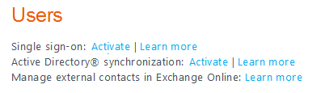
The Learn more link points you to the page Prepare for single sign-on of the online documentation. Key related information is sum-up in the next section.
The Activate link corresponds to the page Set up and manage single sign-on. The page guides you through all of the 10 steps for setting up the single sign-on feature (as well as the required directory synchronization that is not covered in this paper).
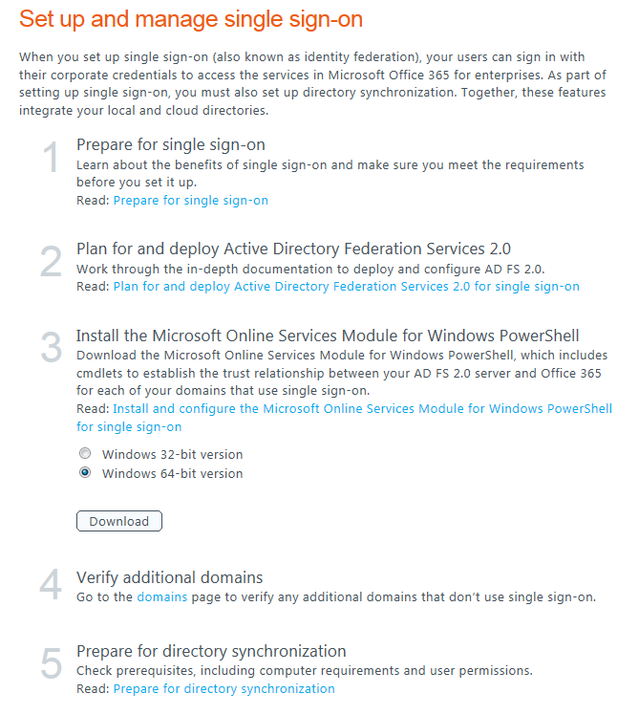
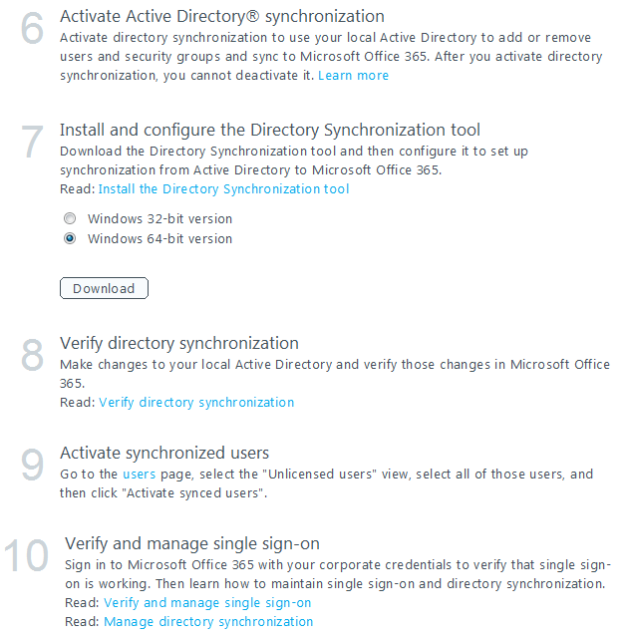
The page Single Sign-on Roadmap provides an overview of these steps.

Preparing for single sign-on
The article Prepare for single sign-on covers the operations that must be conducted in order to prepare the on-premise organization’s IT environment for single sign-on and a successful deployment of Federated Identities. The organization’s on-premise Active Directory must indeed have certain settings configured in terms of both the structure and the use of the Active Directory domain name in order to work properly with single sign-on.
To prepare the Active Directory environment, we highly recommend running the Microsoft Office 365 for enterprises Deployment Readiness Tool (Office365DeploymentReadinessTool.exe) that accompanies the Microsoft Office 365 Deployment Guide.
This tool inspects the Active Directory environment and provides a report that includes information about whether or not you are ready to set up single sign-on. If not, it lists the changes you need to make to prepare for single sign-on.
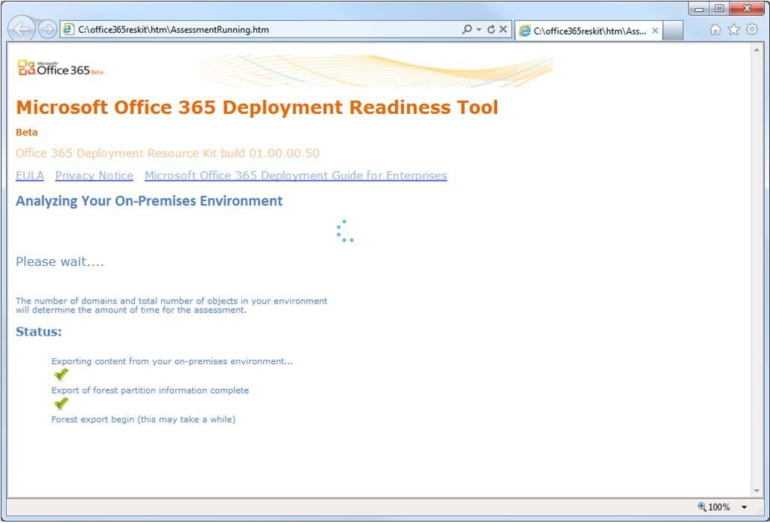
A relevant assessment should cover the following topics:
- UPNs: Federated Identities require corporate users to have a user principal name (UPN), though Active Directory does not. UPNs associate user’s identities in Office 365 for enterprises with the identity in the cloud. Without this value, users may not be able to sign into Office 365 with their corporate credentials.
UPNs that are used for Federated Identities can contain letters, numbers, periods, dashes, and underscores; no other types of characters are permitted. In addition, UPNs cannot end in a period before the at sign (@). In order to address UPN issues, there are a few options for modifying users in bulk. A few tools can be used for this operation such as ADModify.
Matching domains: When Office 365 domain names match the domain names for the local Active Directory, no special considerations regarding the name space are required.
- Sub domains: Configure top-level domains first, and then configure sub-domains. When you register your top-level domain such as idmgt.fr, there is no need to register the subdomains such as legal.idmgt.fr or paris.idmgt.fr. Sub domains are automatically registered for you.
- Local Domains: Local domains that are configured as .local (for example, idmgt.local) or .int (for example idmgt.int) cannot be used for federation because they cannot be accessed from the Internet (that is, they are not publicly routable or identifiable in DNS). You can register public domains with your registrar and then federate that domain with Office 365. Then add the new domain as a UPN domain suffix to your forest, and specify UPNs under the new domain. This will ensure that your federated users’ UPN domain suffix is under the domain that you federated with Office 365.
- Multiple distinct logon domains: Until recently, the use of multiple top level domains for user’s UPN suffixes within an organization (for example, @idmgt.fr or @idmgt.co.uk) requires deploying a separate instance of AD FS 2.0 federation service for each suffix. This no longer applies with the Update Rollup 2 for AD FS 2.0 package (or the previous Update Rollup 1 for AD FS 2.0 package). (see section § 4.3 Installing and configuring the Microsoft Online Services Module).
- Multiple forests: Multiple forests are not currently supported for Federated Identities.

Planning and deploying AD FS 2.0
As already covered, you must have an on-premise AD FS 2.0 infrastructure in place in order to leverage the single sign-on feature of Office 365 and to authenticate the corporate users to Office 365 using the Federated Identities. The following section explores the various AD FS 2.0 implementation scenarios for Office 365 so that you can determine the one that best fits your end users scenarios, requirements, etc.
We recommend a careful and parallel read of the article Plan for and deploy Active Directory Federation Services 2.0 for use with single sign-on that guides through complementary considerations for the final choice of the scenario.

AD FS 2.0 implementation scenarios for Office 365
As with most enterprise-level services, the AD FS 2.0 federation service can be implemented in a variety of ways, based on business needs. More specifically for the single sign-on feature of Office 365, and as described in the article Office 365 Identity Federation service implication of AD FS 2.0 implementations scenarios, the following AD FS 2.0 implementation scenarios depict how an on-premise AD FS 2.0 federation service is published to the Internet.
Each outlined scenario can be varied by using a standalone AD FS 2.0 federation server instead of a server farm. However, it is always a Microsoft best-practice recommendation for all critical infrastructure services to be implemented by using high-availability technology to avoid loss of access.
On-premise AD FS 2.0 federation service availability directly affects Office 365 service availability for Federated Identities, and its service level is the responsibility of the Office 365 customer.

Scenario 1 - Fully-implemented AD FS 2.0
An AD FS 2.0 federation server farm services Active Directory client requests through single sign-on authentication. An AD FS 2.0 (load balanced) federation server proxy exposes those core authentication services to the Internet by relaying requests and responses back and forth between Internet clients and the internal AD FS 2.0 environment.
Figure Fully-implemented AD FS 2.0 implementation scenario
From the above figure, you can see that corporate users would be directed to the AD FS 2.0 load-balanced federation server farm internal endpoint but external users will have to use the AD FS 2.0 load-balanced federation server proxy to access the federation service.
It should be noted that, from an Office 365 perspective, a proxy is not only something useful for external users in order to redirect client authentication requests coming from outside the corporate network to the federation server farm. Such a proxy is indeed required in order for Outlook (2007 or 2010) to connect to Exchange Online using a Federated Identity. Without a proxy in place, Outlook profile creation will continually prompt for credentials (or you'll get a 401 HTTP response instead).
To sum up, a proxy enables the following user scenarios:
- Work computer, roaming: Users who are logged on to domain-joined computers with their corporate credentials, but who are not connected to the corporate network (for example, a work computer at home or at a hotel), can access the services in Office 365.
- Home or public computer: When the user is using a computer that is not joined to the corporate domain, the user must sign in with their corporate credentials to access the services in Office 365.
- Smart phone: On a smart phone, to access the services in Office 365 such as Microsoft Exchange Online using Microsoft Exchange ActiveSync, the user must sign in with his corporate credentials.
- Microsoft Outlook or other email clients: The user must sign in with his corporate credentials to access their Office 365 email if they are using Outlook (2007 or 2010) or an email client that is not part of Office; for example, an IMAP or POP client.
This implementation scenario is fully supported by Office 365 Support Services and corresponds to a Microsoft best practice. This scenario is the optimal configuration for most medium to large enterprise organizations. Depending on the load, more servers may also be required for authentication. Considering the above, the AD FS 2.0 deployment should be scaled to service all of the requests to online service and not only for the Microsoft Online Portal (MOP), the SharePoint Online portals, and Outlook Web Apps (OWA) traffics.

Scenario 2 - Firewall-published AD FS 2.0
An AD FS 2.0 federation server farm services Active Directory client requests through single sign-on authentication. A TMG server (or server farm) exposes those core authentication services to the Internet by reverse proxy.
Important note:
Extended Authentication Protection (EAP) must be disabled on the AD FS 2.0 federation server farm for this to work, which weakens the security profile of the system as described in the article Internet-based client computers cannot authenticate after you configure Active Directory Federation Services (AD FS) in a “firewall-published” configuration. For a security standpoint, this is not recommended.

For this scenario to be supported by Office 365 Support Services, the following conditions must be true:
- The reverse proxy of HTTPS (port 443) traffic between the Internet client and the federation server must be transparent;
- The federation server must receive a faithful copy of SAML requests from the Internet client;
- Internet clients must receive faithful copies of SAML responses as though directly attached to the on-premise federation server.
The article Troubleshooting Active Directory Federation Services availability issues when using Forefront Threat Management Gateway 2010 lists common configuration problems that can cause this configuration to fail.

Scenario 3 - Non-published AD FS 2.0
An AD FS 2.0 federation server farm services Active Directory client requests through single sign-on authentication, and the server farm is not exposed to the Internet by any method.
Outlook rich clients cannot connect to Exchange Online resources as described in the article Federated users cannot connect to Exchange Online mailbox. Section § 5.3 Understanding the MEX/rich client profile authentication flow provides additional explanations on this.
Furthermore, Internet clients (including mobile devices) cannot use Office 365 resources. Consequently, one can understand that, for service level reasons, this is not a recommended scenario as it does not provide the fully-advertised suite of services that are supported by the single sign-on feature of Office 365. Under these circumstances, this scenario is however supported by Office 365 Support Services.
On-premise administrators must periodically refresh federation trust data manually by using the Update-MSOLFederatedDomain command in the Microsoft Online Services Module for Windows PowerShell tool (see section § 4.3.1 Installing the Microsoft Online Services Module). For more information, please refer to the section entitled Update trust properties of the article Verify and manage single sign-on.

Scenario 4 - VPN-published AD FS 2.0
An AD FS 2.0 federation server (or server farm) services Active Directory client requests through single sign-on authentication, and the server or server farm is not exposed to the Internet by any method. Internet clients connect to and use AD FS 2.0 federation service only through a virtual private network (VPN) connection to the on-premise network environment.
Unless Internet clients (including mobile devices) are VPN-capable, they cannot use the services in Office 365. For service level reasons, this is not recommended.
For this scenario to be supported by Office 365 Support Services, the following conditions must be true:
- The client can connect to the AD FS federation service by DNS name through HTTPS (port 443).
- The client can connect to the Office 365 endpoints by DNS name by using appropriate ports/protocols.
- Single sign-on for VPN/Internet users is possible with this scenario, but it is not supported.
Likewise compared to the previous scenario, On-premise administrators must periodically refresh federation trust data manually by using the Update-MSOLFederatedDomain command in the Microsoft Online Services Module for Windows PowerShell tool (see section § 4.3.1 Installing the Microsoft Online Services Module).

Building the AD FS 2.0 infrastructure
Due to the number of planning options available and related settings to consider, providing a step-by-step guide for building the AD FS 2.0 infrastructure or adapting an existing one is outside the scope of this paper.
In addition to the article Plan for and deploy Active Directory Federation Services 2.0 for use with single sign-on, you can refer to the Microsoft TechNet Active Directory Federation Services (AD FS) 2.0 documentation for detailed information on AD FS 2.0. For instance, the article Install the AD FS 2.0 Software provides installation instructions along with nice checklists through many of the planning options available. If you’re considering the first scenario “Fully-implemented AD FS 2.0”, you cannot install and configure the proxy option before you have the AD FS 2.0 federation service installation completed.
The AD FS 2.0 software package (AdfsSetup.exe) can be downloaded from Active Directory Federation Services 2.0 RTW. The Update Rollup 2 for AD FS 2.0 must be applied to all AD FS 2.0 federation server and federation server proxy servers that are being deployed. For the download of the package, please see article 2681584 Description of Update Rollup 2 for Active Directory Federation Services (AD FS) 2.0

Installing and configuring the Microsoft Online Services Module
Once the AD FS 2.0 infrastructure is built according to the selected implementation scenarios (see section § 4.2.1 AD FS 2.0 implementation scenarios for Office 365), we can now move on to installing the Microsoft Online Services Module for Windows PowerShell tool.
Note:
This tool requires the Microsoft Online Services Sign-In Assistant (MSO SIA), which is included in the Office 365 Desktop Setup application or available as a separate download: Microsoft Online Services Sign-In Assistant for IT Professionals RTW.

Running this tool basically adds a set of cmdlets to the environment and a PowerShell interface so you can complete the configuration of the single sign-on feature. With the added Windows PowerShell cmdlets, you can configure the trust between the internal domain(s) and the Office 365 Identity Platform. This will allow the users’ requests for authentication to be redirected to the AD FS 2.0 federation service URL.
This will also upload the public key for the certificate used for AD FS 2.0 token signing as well as advertise the claims and domain(s) to be federated. If there are ever any changes to the AD FS 2.0 configuration, you will have to update the configuration again which is explained later in this paper.

Installing the Microsoft Online Services Module
Administrative privileges are needed onto an AD FS 2.0 federation server session to install the Microsoft Online Services Module and to configure the single sign-on.
To install the tool, proceed as follows:
- From an AD FS 2.0 federation server session, logged on as the domain administrator, navigate on the Microsoft Online Portal (MOP) to the step 2 of the page Install and configure the Microsoft Online Services Module for Windows PowerShell for single sign-on.
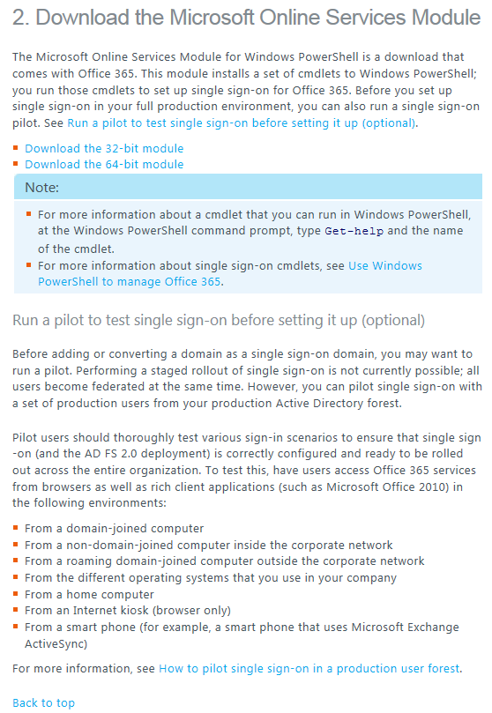
- Click the download link that corresponds to the appropriate version (32-bit vs. 64-bit) of the Microsoft Online Services Module (AdministrationConfig-en.msi) and click Run to execute it.
Note:
The link is also available through the page Set up and manage single sign-on from the Admin portion of the MOP under the Users section. This was described earlier for the download point for the AD FS 2.0 installation and relates to the step 3 in the process.

The wizard Microsoft Online Services Module for Windows PowerShell Setup pops up.
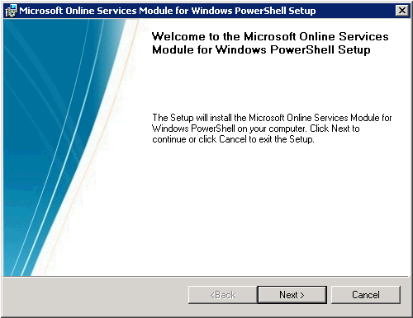
- On the Welcome page, select the Next option.
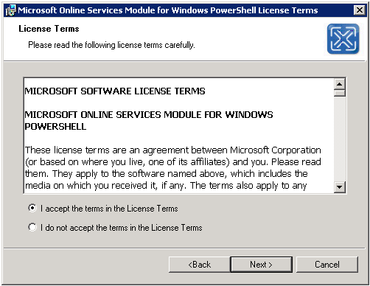
- On the License Terms page, select I accept the terms in the License terms and click Next.
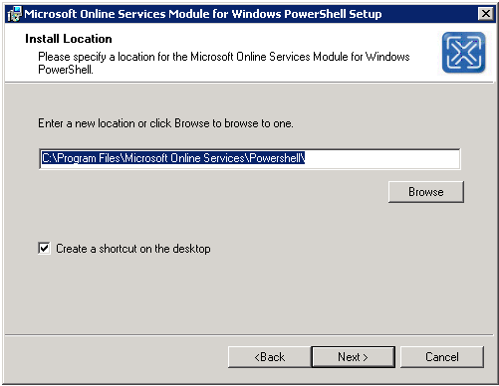
- On the Install Location page, select the defaults for the installation location and click Next.
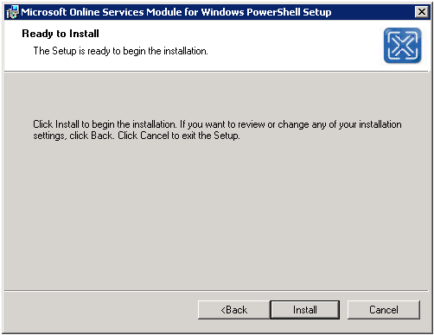
- On the Ready to Install page, click Install.
- On the completion page, click Finish option.
At this stage, and as described in Windows PowerShell cmdlets for Office 365, the following cmdlets perform tasks related to single sign-on (also known as identity federation), such as adding a new single sign-on domain (also known as identity-federated domain) to Office 365.
Table : Windows PowerShell Single Sign-On Cmdlets for Office 365
Single Sign-On Cmdlet | Description
New-MsolFederatedDomain | Adds a new single sign-on domain to Office 365 and configures the relying party trust settings between the on-premise AD FS 2.0 federation service and Office 365. Due to domain verification requirements, you may need to run this cmdlet several times in order to complete the process of adding the new single sign-on domain.
Convert-MsolDomainToStandard | Converts the specified domain from single sign-on to standard authentication. This process also removes the relying party trust settings in the AD FS 2.0 federation service and Office 365. After the conversion, this cmdlet will convert all existing users from single sign-on to standard authentication. Any existing user who was configured for single sign-on will be given a new temporary password as part of the conversion process. Each converted user name and new temporary password will be recorded in a file for reference by the administrator. The administrator can then distribute the new temporary password to each converted user to enable the user to sign in to Office 365.
Convert-MsolDomainToFederated | Converts the specified domain from standard authentication to single sign-on, including configuring the relying party trust settings between the AD FS 2.0 federation service and Office 365. As part of converting a domain from standard authentication to single sign-on, each user must also be converted. This conversion happens automatically the next time a user signs in; no action is required by the administrator.
Get-MsolFederationProperty | Gets key settings from both the AD FS 2.0 federation service and Office 365. You can use this information to troubleshoot authentication problems caused by mismatched settings between the AD FS 2.0 federation service and Office 365.
Get-MsolDomainFederationSettings | Gets key settings from Office 365. Use the Get-MsolFederationProperty cmdlet to get settings for both Office 365 and the AD FS 2.0 federation service.
Remove-MsolFederatedDomain | Removes the specified single sign-on domain from Office 365 and the associated relying party trust settings in AD FS 2.0. Note: If the domain specified has objects associated with it, you will not be able to remove the domain.
Set-MsolDomainFederationSettings | Is used to update the settings of a single sign-on domain.
Set-MsolADFSContext | Sets the credentials to connect to Office 365 and to the AD FS 2.0 federation service. This cmdlet must be run before making other Single Sign-On cmdlet calls. If this cmdlet is called without parameters, the user will be prompted for credentials to connect to the different systems. When the AD FS 2.0 federation service is used remotely, the user must specify the computer name of the primary AD FS 2.0 server. Note that the specified logfile is shared by all single sign-on cmdlets for the session. A default logfile is created if one is not specified.
Update-MsolFederatedDomain | Changes settings in both the AD FS 2.0 federation service and Office 365. It is necessary to run this cmdlet whenever the URLs or certificate information within AD FS 2.0 change due to configuration changes or through regular maintenance of the certificates, such as when a certificate is about to expire. This cmdlet should also be run when changes occur in Office 365. To confirm that the information in the two systems is correct, the Get-MsolFederationProperty cmdlet can be used to retrieve the settings.

Connecting Windows PowerShell to the Microsoft Online Services
The next step is to open the Windows PowerShell from Microsoft Online Services Module for Windows PowerShell and connect the Windows PowerShell to the online domain using your Online Administrator Credentials.
To connect Windows PowerShell to the Microsoft Online Services, proceed as follows:
- Click Start > All Programs > Microsoft Online Services > Microsoft Online Services Module for Windows PowerShell to open a Windows PowerShell command prompt with the single sign-on cmdlets.
- From the Windows PowerShell command prompt, type Connect-MsolService. This command prompts for your Microsoft Online Admin credentials and sets the context of the Windows PowerShell as Online Administrator.
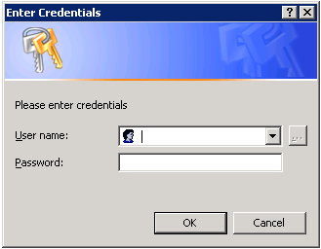

PS C:\Windows\system32> Connect-MsolService
PS C:\Windows\system32> _

Note:
If there is a newer version of the Windows PowerShell module, you will see yellow warning text explaining that a newer version is available. You should always ensure that you run the latest version of the module.

- If you were not on the AD FS 2.0 server, you would normally need to execute the command Set-MsolADFSContext to set an AD FS context server. This command prompts for the host name of an AD FS 2.0 server.

PS C:\Windows\system32> Set-MsolADFSContext

cmdlet Set-MsolADFSContext at command pipeline position 1
Supply values for the following parameters:
Computer: idmgt-dc
PS C:\Windows\system32> _

You do NOT need to execute this cmdlet when you are on the AD FS 2.0 server.

Creating a new domain as a federated domain
To create a new domain as a federated domain from a Windows PowerShell command prompt, and after having connected Windows PowerShell to Microsoft Online Services, proceed as follows:
- Connect Windows PowerShell to the Microsoft Online Services (see eponym section § 4.3.2 Connecting Windows PowerShell to the Microsoft Online Services).
- Run the command New-MsolFederatedDomain –DomainName <domain name>.

PS C:\Windows\system32> New-MsolFederatedDomain –DomainName demo.idmgt.archims.fr
WARNING: Please verify demo.idmgt.archims.fr domain owership by adding a DNS
demo.idmgt.archims.fr CNAME record targeting ps.microsoftonline.com at your
domain registrar. More information can be found
http://technet.microsoft.com/en-us/library/cc742578.aspx
PS C:\Windows\system32> _

Figure First running of the new-MsolFederatedDomain cmdlet
- Create a domain proof of ownership TXT record (or, if you prefer, an MX record) for the domain that is registered at your domain name registrar, e.g.:
Alias or host: demo.idmgt.archims.fr
Value: v=verifydomain MS=ms90115610
TTL: 1 hour
Office 365 indeed uses a DNS record that you create at your registrar to confirm that you own the domain. For additional information, please refer to the articles Add your domain to Office 365 and Verify a domain at any domain name registrar.
- Run the command New-MsolFederatedDomain –DomainName <domain name> a second time to finalize the process after you have created the domain record per the warning above.

PS C:\Windows\system32> New-MsolFederatedDomain –DomainName demo.idmgt.archims.fr
Successfully added demo.idmgt.archims.fr domain.
PS C:\Windows\system32> _
This verifies domain proof of ownership. The newly registered domain propagates out to Office 365 services like Exchange Online:
- The namespace is reserved as a “Federated Namespace”;
- The AD FS 2.0 federation service public endpoint is set for each namespace to https://adfs.demo.idemgt.archims.com/adfs/ls/;
- Exchange Online creates the registered domain as Accepted Domain.

Figure Second running of the new-MsolFederatedDomain cmdlet
Note:
The domain can also be added from the Microsoft Online Portal (MOP) as well. The steps would be identical and the domain would still have to be verified in the same way. If the domain was added through the MOP the user would simply have to convert the domain to federated from the command line, so it is easier to do it all in one shot from the command line. The steps for converting a domain are described hereafter.

After the above steps are completed, you can verify that the domain was added correctly and is federated via the Microsoft Online Portal (MOP). When you are in MOP, just select the Admin option at the top in the navigation bar. Then in the left column select the Domains under User Management, then select the domain that you just added and you will see that it is federated.
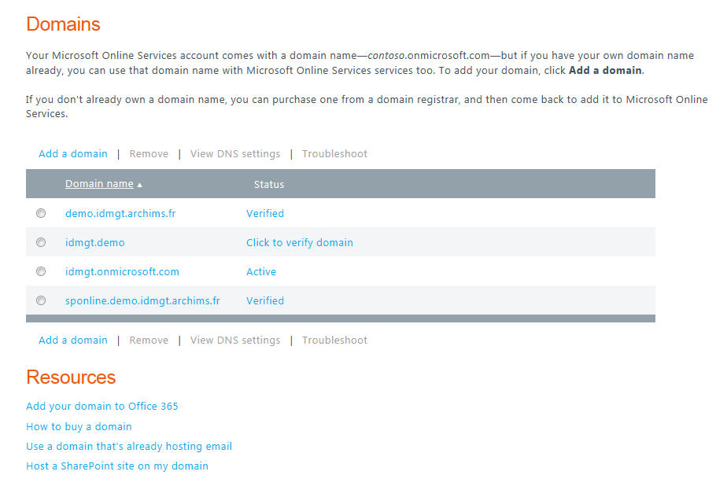
When the Domain is “Federated”, you will no longer have the option to add the domain suffix to the Microsoft Online user accounts. The users will need to be created on premise in order for them to have the federated domain name available to them. You can still create accounts directly in the cloud, but they cannot have the federated domain name assigned to them unless they are created on-premise.

Updating any changes to the AD FS 2.0 configuration
There are a lot of instances when you may need to update the Office 365 Identity Platform with new settings from the AD FS 2.0 federation service.
Federation metadata from the AD FS 2.0 federation service, such as token-signing certificate, federation service name, and federation service identifier, is indeed synchronized with the Office 365 Identity Platform only once during initial conversion of the tenant domain to a federated type.
If any part of the metadata of AD FS 2.0 changes on-premise, the trust relationship with Office 365 may be broken completely, causing outages which could be company-wide for the tenant.
The following is a list of the common issues that will require you to update the information if:
- The SSL/TLS certificate expires on the AD FS 2.0 federation server(s) and/or (load-balanced) AD FS 2.0 federation server proxy (typically every year);
- A new certificate is issued to the AD FS 2.0 federation server(s) and/or (load-balanced) AD FS 2.0 federation server proxy;
- The AD FS 2.0 implementation scenario has evolved (see section § 4.2.1 AD FS 2.0 implementation scenarios for Office 365);
- The URL of an AD FS 2.0 federation service’s endpoint has changed;
- There are any mismatches with the certificate(s) or the configuration itself. Users with a federated identity may get the following error when using corporate credentials to access Office 365: “There was a problem accessing the site. Try to browse to the site again.”
- Etc.
To address all of the issues you would need to make the on-premise information consistent with the information in the Office 365 Identity Platform by updating the current configuration information.
To manually update the configuration, proceed as follows:
- Connect Windows PowerShell to the Microsoft Online Services (see eponym section § 4.3.2 Connecting Windows PowerShell to the Microsoft Online Services).
- Run the command Update-MsolFederatedDomain –DomainName <domain name>.
The Microsoft Office 365 Federation Metadata Update Automation Installation Tool can be used instead to automate the update of the Microsoft Office 365 federation metadata regularly to ensure that any changes configured in the AD FS 2.0 federation service are replicated to the Office 365 Identity Platform automatically.
This tool runs as a scheduled task, securely storing Microsoft Online (MSOL) credentials in Credential Manager on an AD FS 2.0 server, and it periodically pushes new metadata to Office 365 to avoid or minimize outages due to production metadata changes.
To automatically update the configuration, proceed as follows:
- Log in to the AD FS 2.0 server as an administrator.
- Download the text file O365-Fed-MetaData-Update-Task-Installation.ps1.txt from the online gallery, and save the text file as a .ps1 file on the Desktop of the AD FS 2.0 server.
- Right-click the newly created file O365-Fed-MetaData-Update-Task-Installation.ps1, click Properties, click Unblock in the General tab, and click OK.
- From the Start menu, launch an administrative Windows PowerShell window, and change directory to the Desktop.
- Run the following command and press Y so you are able to execute scripts on the server:

PS C:\Users\Administrator> Set-ExecutionPolicy Unrestricted

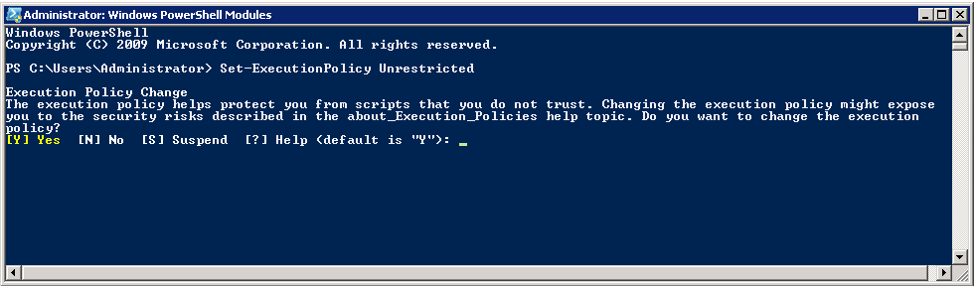
- Execute the .ps1 file you saved in step 2.

PS C:\Users\Administrator> cd .\Desktop
PS C:\Users\Administrator>.\O365-Fed-MetaData-Update-Task-Installation.ps1

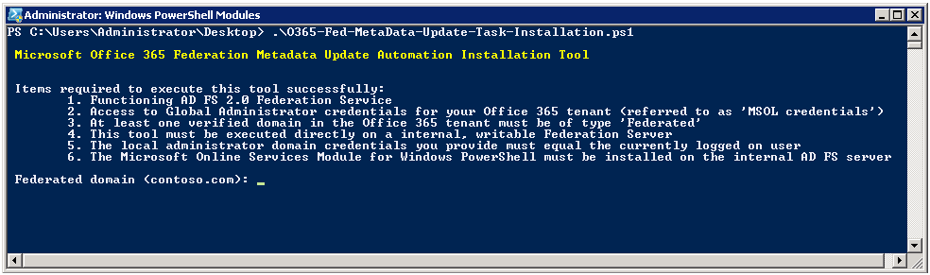
- Type and confirm your federated domain, for example “demo.idmgt.archims.fr”.
- Type your global administrator account and password such as:
Username: admin@idmgt.onmicrosoft.com
Password: ****************
If you successfully enter your online credential, you will see the following message:
Success
Added MSOL credentials to the local Credential Manager
- Type the password for the currently logged on administrator.
- The tool will proceed through to the finish.
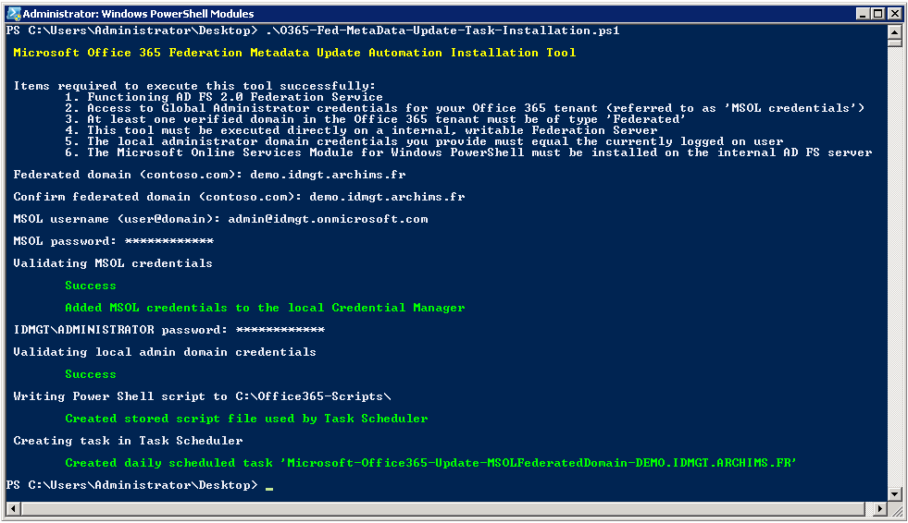
The specified MSOL credentials are securely stored on the AD FS 2.0 server so that the Microsoft Online Service Module for Windows PowerShell cmdlets can be executed as a scheduled task in order to keep the metadata between the on-premise AD FS 2.0 federation service and Office 365 fresh.
To see the MSOL credentials, proceed as follows:
- Click Start, type “Credential” into the Search field, and click Credential Manager in the results.
- See the new generic credential named Microsoft-Office365-Update-MSOLFederatedDomain-DEMO.IDMGT.ARCHIMS.FR with the username of the global administrator you typed into the tool (admin@idmgt.onmicrosoft.com).
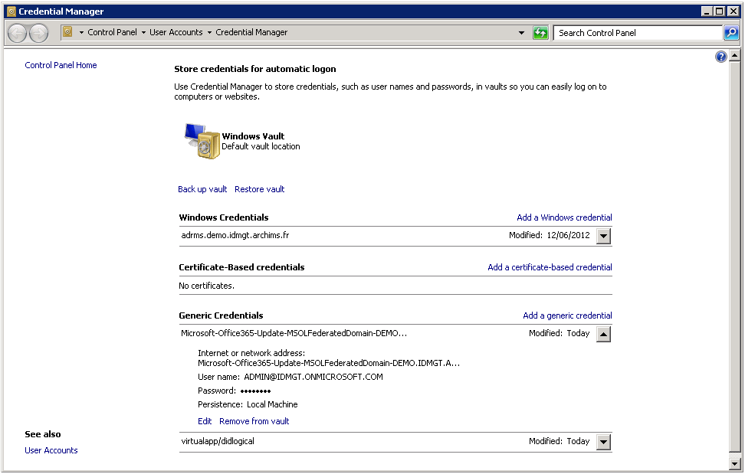
- Close Credential Manager.
To see the created scheduled task, proceed as follows:
- Click Start, type “Task” into the Search field, and click Task Scheduler in the results.
- Select the Task Scheduler Library and view the task in the list named Microsoft-Office365-Update-MSOLFederatedDomain-DEMO.IDMGT.ARCHIMS.FR
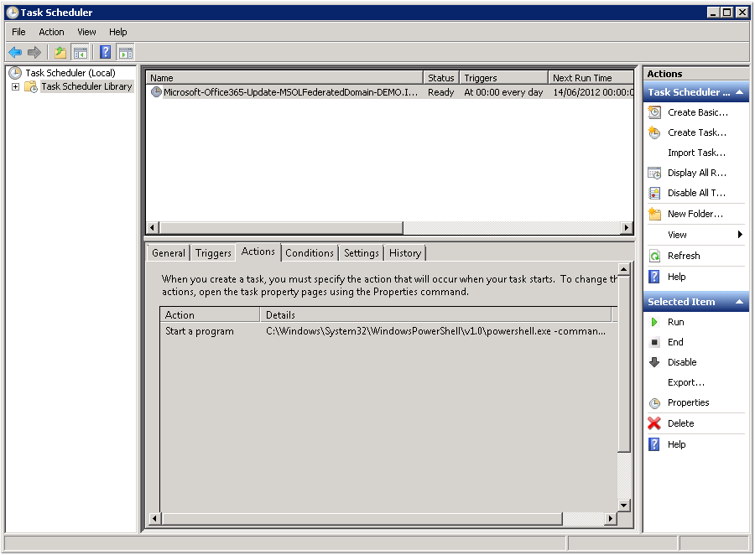
  - Notice that this task runs every day at midnight.
  - The task runs as your administrator account you specified in the tool.
  - The action that it performs is:

C:\Windows\System32\WindowsPowerShell\v1.0\powershell.exe –command C:\Office365-Scripts\Microsoft-Office365-Update-MSOLFederatedDomain-DEMO.IDMGT.ARCHIMS.FR.ps1

- Minimize Task Scheduler.
- Explore to C:\Office365-Scripts.
- Notice the .ps1 file named Microsoft-Office365-Update-MSOLFederatedDomain-DEMO.IDMGT.ARCHIMS.FR.ps1 and the log file named History.log.
- Open History.log, and you will see where the tool was installed.

Verifying the single sign-on
As suggested in the article Verify and manage single sign-on, it is always best when verifying (and/or) troubleshooting the single sign-on to keep it as simple as possible. Even if an encountered issue concerns Lync or Exchange Online access, it is best just accessing the Microsoft Online Portal (MOP) with the on-premise credentials to verify if the single sign-on is working. This will allow you to verify if the issue is application/service specific or if the issue is with single sign-on. If the user can log in to MOP but cannot log into OWA with the corporate credentials then you can be sure the issue is not related to single sign-on.
To verify the single sign-on, proceed as follows:
- Open Internet Explorer, and then navigates to https://portal.microsoftonline.com to access the Microsoft Online Portal (MOP). You will see you are immediately redirected to the login.microsoftonline.com URL which is the Identity Provider for the Microsoft Online Services.
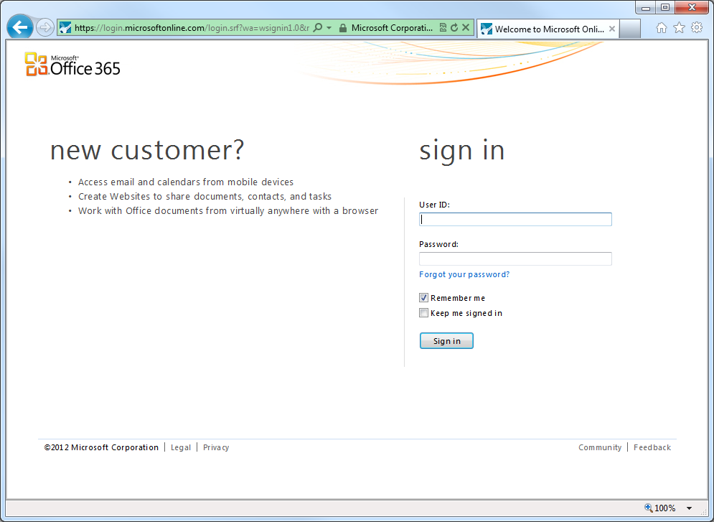
- Type your on-premise corporate UPN in User ID.
- Click inside Password. This triggers a home realm discovery (HRD) process for federated identities to see if the domain part of the UPN is federated.
Note:
If you turn on HTTP tracing on IE or observe the traffic via a tool like the Fiddler2 HTTP trace application, you can see that the login.microsoftonline.com URL is calling GetUserRealm as part of the home realm discovery (HRD) process. You will also notice that there results show the AD FS 2.0 federation service passive endpoint information (see section § 5.1.5 Endpoints).

- If single sign-on is correctly set up, you will notice that the user cannot even type here password. Password will be shaded. The user is provided a link to the AD FS 2.0 federation service. You will see the following message: “You are now required to sign at <your company>”.
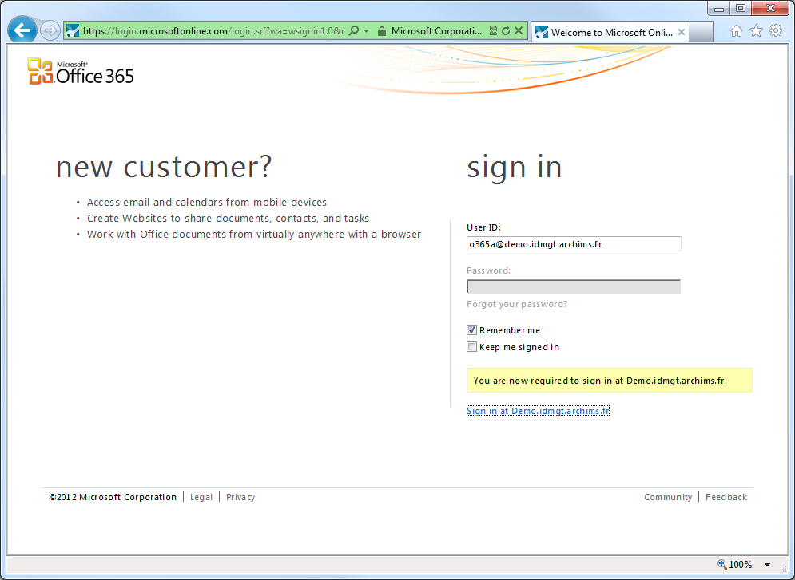
- Click the Sign in at <your company> link, i.e. the Sign in at Demo.idmgt.archims.fr link from the above screen capture. This is a redirect link to send the user to the AD FS 2.0 federation service passive endpoint. The user will then provide the on-premise credentials. If the user was domain connected the AD FS 2.0 endpoint would be hit but without the credential prompt.
If you are able to sign in, the single sign-on has been set up correctly.
.

Understanding how federated authentication works in Office 365
This section aims at providing additional information on the configuration established via the Microsoft Online Services Module for Windows PowerShell in order to setup single sign-on. It focuses on an explanation of the resulting settings on AD FS 2.0 as well as the several types of interaction between the key components involved in the transaction, i.e. the client, the on-premise AD FS 2.0 infrastructure, the Office 365 Identity Platform (and its sign-in service), and the services in Office 365.

Understanding the AD FS 2.0 configuration

A quick recap on the AD FS 2.0 Claims pipeline and engine
As previously described, an AD FS 2.0 federation service is a STS that relies on a claims-based model. In this model, the claims pipeline (see The Role of the Claims Pipeline) represents the path that claims must follow through the federation service before they can be issued as part of a SAML token.
The federation service manages the entire end-to-end process of flowing claims through the various stages of the claims pipeline, which also includes the processing of different claim rule sets by the claim rule-based engine (see The Role of the Claims Engine).
The claim engine handles three primary tasks that relate to a specific stage of the claims pipeline:
- Accepting incoming claims from a claim provider (Acceptance Transform Rules);
- Authorizing claims requesters (Issuance Authorization Rules);
- Issuing outgoing claims to a relying party (Issuance Transform Rules).
Figure AD FS 2.0 Claims Pipeline
Besides the claim engine, which processes the claim rules as part of the claims pipeline, the AD FS 2.0 configuration has 3 main relationships to control this entire function:
- Attribute Store: This is where the AD FS 2.0 federation service queries attributes in order to source claims. If Active Directory Domain Services (AD DS) is declared by default, the AD FS 2.0 federation service can also use attributes coming from several other attribute stores, such as Active Directory Lightweight Directory Services (AD LDS), Microsoft SQL Server databases, and other data sources.
- Claim Provider Trust: This is where the federation trust between the AD FS 2.0 federation service and the Claim provider is configured. Based on a set of rules called the Acceptance Transform Rules, the claims from the claims provider will be filtered or pass-through to the Relying Party Trust in the context of the transaction. The on-premise Active Directory is the claims provider about single sign-on with Office 365.
- Relying Party Trust: This is where the federation trust between the AD FS 2.0 federation service and the relying party is configured. Here, the federation service controls which users have access to the relying party based on the Issuance Authorization Rules, and then it issues claims to the relying party based on Issuance Transform Rules. The Office 365 Identity Platform is the relying party about single sign-on with Office 365. Conversely, you can say that, in Office 365, Exchange Online, SharePoint Online, etc. are the relying parties of the Office 365 Identity Platform.

Claim Descriptions
The SAML 1.1 logon token issued by the AD FS 2.0 federation services to the Office 365 Identity Platform relying party contains claims sourced from the on-premise Active Directory claims provider (see next section) that allows the Office 365 sign-in service to match the user to a shadow identity in the cloud:
- The User Principle Name (UPN) of the corporate user, which is tied to the provisioned value for the user thanks to the directory synchronization.
- A unique, rename-safe identifier for the user, which must remain constant for the lifetime of the object in the cloud. This otherwise could lead to duplicate objects and unexpected synchronization errors.
This is by default is the on-premise Active Directory Object GUID (ImmutableID). The Object GUID ByteArray is converted into Base64 string.
Consequently, and for that specific purpose, you can see the following 2 claim descriptions:
- UPN (http://schemas.xmlsoap.org/ws/2005/05/identity/claims/upn).
- Source user ID (http://schemas.microsoft.com/LiveID/Federation/2008/08/ImmutableID).

On-premise Active Directory Claims Provider Trust
The following rules are declared for the Acceptance Transform Rules set regarding the Active Directory attribute store.
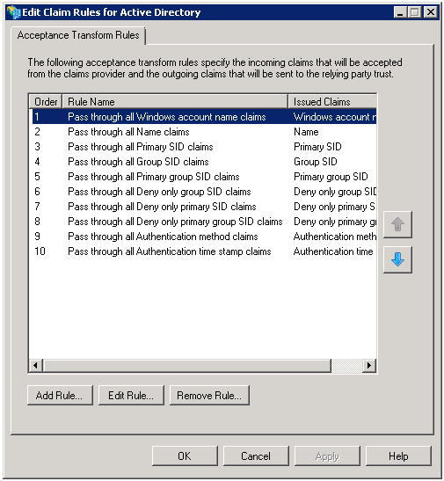
The incoming claim types are as follows:
- Windows account name;
- Name;
- Primary SID;
- Group SID;
- Primary Group SID;
- Deny only group SID;
- Deny only primary SID;
- Deny only group SID;
- Authentication method;
- Authentication time stamp.

Microsoft Office 365 Identity Platform Relying Party Trust
The creation of the domain as a Federated domain with the Microsoft Online Services Module cmdlets (see section § 4.3.3 Creating a new domain as a federated domain) results in the automated definition of a new Microsoft Office 365 Identity Platform relying party trust.

Properties
The Monitoring tab of the Microsoft Office 365 Identity Platform properties shows the URL from where the Office 365 sign-in service metadata are retrieved: https://nexus.microsoftonline-p.com/federationmetadata/2007-06/federationmetadata.xml.
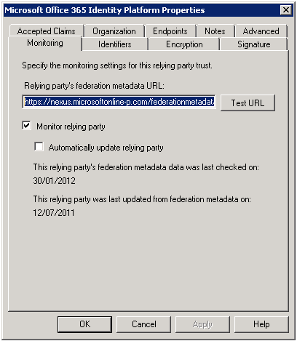
This also shows that the trust definition leverages the AD FS 2.0 capability to monitor the relying party metadata and to automatically update the trust definition to reflect the relying party current settings.
“If federation is broken. It's PKI. If it is not PKI, there's a typo. If you typed it correctly (case counts!). It's PKI”
Laura E. Hunter
This seamlessly takes into account any change that occurs on the Office 365 Identity Platform side. Such a capability greatly lessens the administrative effort to maintain the relying party trust on the AD FS 2.0 federation service side.
Conversely, this is the role devoted to:
- The Microsoft Online Services Module for Windows Powershell cmdlet Update-MsolFederatedDomain to manually
-or-
- The Microsoft Office 365 Federation Metadata Update Automation Installation Tool to automatically
Update the trust information, i.e. the federation metadata, when information changes on the AD FS 2.0 federation service side and to reflect it on the Office 365 Identity Platform side (see section § 4.3.4 Updating any changes to the AD FS 2.0 configuration).
The Office 365 sign-in service metadata are as follows. The general syntax and semantics of metadata are defined in the OASIS Web Services Federation Language (WS-Federation) Version 1.2.

<?xml version="1.0" encoding="utf-8"?>
<EntityDescriptor wsu:Id="0c0d1ca7-7292-4bc6-801c-f880f6098f4e" entityID="urn:federation:MicrosoftOnline"
xmlns="urn:oasis:names:tc:SAML:2.0:metadata"
xmlns:wsu="http://docs.oasis-open.org/wss/2004/01/oasis-200401-wss-wssecurity-utility-1.0.xsd">
<RoleDescriptor xsi:type="fed:SecurityTokenServiceType"
protocolSupportEnumeration="http://schemas.xmlsoap.org/ws/2005/02/trust http://docs.oasis
open.org/wsfed/federation/200706" xmlns:xsi="http://www.w3.org/2001/XMLSchema-instance"
xmlns:fed="http://docs.oasis-open.org/wsfed/federation/200706">
<KeyDescriptor use="signing" wsu:Id="stscer">
<KeyInfo xmlns="http://www.w3.org/2000/09/xmldsig#">
<X509Data>
<X509Certificate>MIICWzCCAcSgAwIBAgIJANswIPW/+LJFMA0GCSqGSIb3DQEBBQUAMCkxJzAlBgNV
BAMTHkxpdmUgSUQgU1RTIFNpZ25pbmcgUHVibGljIEtleTAeFw0xMDA3MTYyMTI0
NTZaFw0xNTA3MTUyMTI0NTZaMCkxJzAlBgNVBAMTHkxpdmUgSUQgU1RTIFNpZ25p
bmcgUHVibGljIEtleTCBnzANBgkqhkiG9w0BAQEFAAOBjQAwgYkCgYEAlM7mGMQ6
Ha0JP8odYF4ArNF294zQzoRoR7PSv88tyHD/6wINeVn/ebD+XVI9ebRmRFdJYRFr
dqOrYwJOPmq9bG+zF2HblKX718BcAKw7Ku6iqkk0YwtCM1hijr9FlyBGIS9XoE+Y
y/qs+WNJyaUnXIw0YMwvoj0ev0KOtd6X7ekCAwEAAaOBijCBhzAdBgNVHQ4EFgQU
v0DdCHPD3pifWehnZfE6eCztZj8wWQYDVR0jBFIwUIAUv0DdCHPD3pifWehnZfE6
eCztZj+hLaQrMCkxJzAlBgNVBAMTHkxpdmUgSUQgU1RTIFNpZ25pbmcgUHVibGlj
IEtleYIJANswIPW/+LJFMAsGA1UdDwQEAwIBxjANBgkqhkiG9w0BAQUFAAOBgQBP
FFgHrWNtMRHsbjb/YUj67a7YvVnht11yH73oWLDdS/WW4VYHB3RiZuxU07EtIFXk
yjRQ2lmHuza9+IljVKirLw8Zp6CH6tTiZC8WiyRI8cgenztPLO7x1Rwbg5d4bKkV
P0dX7pe/Z6hrouK9Xc8828mjL09OlyiH6L+tZc0hJw==
</X509Certificate>
</X509Data>
</KeyInfo>
</KeyDescriptor>
<KeyDescriptor use="signing" wsu:Id="stsbcer">
<KeyInfo xmlns="http://www.w3.org/2000/09/xmldsig#">
<X509Data>
<X509Certificate>MIICWzCCAcSgAwIBAgIJAOAWPCFtWFILMA0GCSqGSIb3DQEBBQUAMCkxJzAlBgNV
BAMTHkxpdmUgSUQgU1RTIFNpZ25pbmcgUHVibGljIEtleTAeFw0xMDA3MTYyMTI0
MjZaFw0xNTA3MTUyMTI0MjZaMCkxJzAlBgNVBAMTHkxpdmUgSUQgU1RTIFNpZ25p
bmcgUHVibGljIEtleTCBnzANBgkqhkiG9w0BAQEFAAOBjQAwgYkCgYEArFszs9TG
9LSN0yT3PDzEMCql9OAN3qV6vv6HSoJR2E1WFZAXEt9KpO9AwVkD0pxat1DoCztf
dVlhk+ZhD8yv7x1PIzQJsLxC233Ch6pd3riFSJdA0BJtgr7V07You6keKDj6hYWk
Io97zOFMbnR8GrJXxOaAR4bvwaF2osYjY3UCAwEAAaOBijCBhzAdBgNVHQ4EFgQU
m7Ph5zX8u1dUl8zE+5jQ+KarrUYwWQYDVR0jBFIwUIAUm7Ph5zX8u1dUl8zE+5jQ
+KarrUahLaQrMCkxJzAlBgNVBAMTHkxpdmUgSUQgU1RTIFNpZ25pbmcgUHVibGlj
IEtleYIJAOAWPCFtWFILMAsGA1UdDwQEAwIBxjANBgkqhkiG9w0BAQUFAAOBgQBd
aADu9GMezEPONs2wXMXZnwc3BAFWlP+hlp5T+vuVZlSsczyTn9Kmbw3oos8EMmro
GrzuxF3g71533ZnRC+Z+x1rltMXiI7vIcbwY1h3E6nt5X3/q/rhQu2bsCx7D9051
pCdWWSxjYHz2MH29x68OXOF0447aXyCzCg7O7Lj1cw==
</X509Certificate>
</X509Data>
</KeyInfo>
</KeyDescriptor>
<fed:ClaimTypesOffered>
<auth:ClaimType Uri="http://schemas.xmlsoap.org/claims/EmailAddress" Optional="True"
xmlns:auth="http://docs.oasis-open.org/wsfed/authorization/200706">
<auth:DisplayName>
Email Address
</auth:DisplayName>
</auth:ClaimType>
<auth:ClaimType Uri="http://schemas.xmlsoap.org/ws/2006/12/authorization/claims/action"
Optional="True" xmlns:auth="http://docs.oasis-open.org/wsfed/authorization/200706">
<auth:DisplayName>
Action for which the token is valid
</auth:DisplayName>
</auth:ClaimType>
<auth:ClaimType Uri="http://schemas.microsoft.com/ws/2006/04/identity/claims/RequestorDomain"
Optional="True" xmlns:auth="http://docs.oasis-open.org/wsfed/authorization/200706">
<auth:DisplayName>
Domain name of the entity that requested the token on behalf of the user
</auth:DisplayName>
</auth:ClaimType>
<auth:ClaimType Uri="http://schemas.microsoft.com/ws/2006/04/identity/claims/ThirdPartyRequested"
Optional="True" xmlns:auth="http://docs.oasis-open.org/wsfed/authorization/200706">
<auth:DisplayName>
Indicates this token was not requested directly by the user.
</auth:DisplayName>
</auth:ClaimType>
</fed:ClaimTypesOffered>
<fed:TokenTypesOffered>
<fed:TokenType Uri="urn:oasis:names:tc:SAML:1.0"/>
</fed:TokenTypesOffered>
<fed:MexEndpoint>
<EndpointReference xmlns="http://www.w3.org/2005/08/addressing">
<Address>https://login.microsoftonline.com/login.srf</Address>
</EndpointReference>
</fed:MexEndpoint>
<fed:PassiveRequestorEndpoint>
<EndpointReference xmlns="http://www.w3.org/2005/08/addressing">
<Address>https://login.microsoftonline.com/login.srf</Address>
</EndpointReference>
</fed:PassiveRequestorEndpoint>
</RoleDescriptor>

<RoleDescriptor xsi:type="fed:ApplicationServiceType"
protocolSupportEnumeration="http://schemas.xmlsoap.org/ws/2005/02/trust http://docs.oasis-
open.org/wsfed/federation/200706" xmlns:xsi="http://www.w3.org/2001/XMLSchema-instance"
xmlns:fed="http://docs.oasis-open.org/wsfed/federation/200706"
xmlns:mfg="urn:microsoft:live:federation">
<fed:TargetScopes>
<EndpointReference xmlns="http://www.w3.org/2005/08/addressing">
<Address>
https://login.microsoftonline.com/extSTS.srf
</Address>
</EndpointReference>
</fed:TargetScopes>
<fed:ApplicationServiceEndpoint>
<EndpointReference xmlns="http://www.w3.org/2005/08/addressing">
<Address>
https://login.microsoftonline.com/extSTS.srf
</Address>
</EndpointReference>
</fed:ApplicationServiceEndpoint>
<fed:PassiveRequestorEndpoint>
<EndpointReference xmlns="http://www.w3.org/2005/08/addressing">
<Address>
https://login.microsoftonline.com/login.srf
</Address>
</EndpointReference>
</fed:PassiveRequestorEndpoint>
<mfg:FederationMetadataPutEPR>
<EndpointReference xmlns="http://www.w3.org/2005/08/addressing">
<Address>
https://ppsanamespace.service.microsoftonline-p.net/pksecure/ProvisionTrustPK.srf
</Address>
</EndpointReference>
</mfg:FederationMetadataPutEPR>
</RoleDescriptor>

<Signature xmlns="http://www.w3.org/2000/09/xmldsig#">
<SignedInfo>
<CanonicalizationMethod Algorithm="http://www.w3.org/2001/10/xml-exc-c14n#"/>
<SignatureMethod Algorithm="http://www.w3.org/2000/09/xmldsig#rsa-sha1"/>
<Reference URI="#0c0d1ca7-7292-4bc6-801c-f880f6098f4e">
<Transforms>
<Transform Algorithm="http://www.w3.org/2000/09/xmldsig#enveloped-signature"/>
<Transform Algorithm="http://www.w3.org/2001/10/xml-exc-c14n#"/>
</Transforms>
<DigestMethod Algorithm="http://www.w3.org/2000/09/xmldsig#sha1"/>
<DigestValue>aQPeWCSJOS22Dk60yhNDG/NCiIo=</DigestValue>
</Reference>
</SignedInfo>
<SignatureValue>
TCgu1tc0TAuJay2GEPFHlNbwJtXGX203/oEem0gToHNEE6IxOaXgRFduLNqZw/QMJdHgdXPf558E7+GmhQRRSfEiAyXkxQEoh
Q7pvHgujapyo2iSTBgLIT7hme3nxADHvKrlEolKBIh3aBnTz0Eqn1FUB68qvNH7UFuBqTU0bJ0=
</SignatureValue>
<KeyInfo>
<X509Data>
<X509Certificate>
MIICWzCCAcSgAwIBAgIJANswIPW/+LJFMA0GCSqGSIb3DQEBBQUAMCkxJzAlBgNVBAMTHkxpdmUgSUQgU1RTIFNpZ25pbm
cgUHVibGljIEtleTAeFw0xMDA3MTYyMTI0NTZaFw0xNTA3MTUyMTI0NTZaMCkxJzAlBgNVBAMTHkxpdmUgSUQgU1RTIFNp
Z25pbmcgUHVibGljIEtleTCBnzANBgkqhkiG9w0BAQEFAAOBjQAwgYkCgYEAlM7mGMQ6Ha0JP8odYF4ArNF294zQzoRoR7
PSv88tyHD/6wINeVn/ebD+XVI9ebRmRFdJYRFrdqOrYwJOPmq9bG+zF2HblKX718BcAKw7Ku6iqkk0YwtCM1hijr9FlyBG
IS9XoE+Yy/qs+WNJyaUnXIw0YMwvoj0ev0KOtd6X7ekCAwEAAaOBijCBhzAdBgNVHQ4EFgQUv0DdCHPD3pifWehnZfE6eC
ztZj8wWQYDVR0jBFIwUIAUv0DdCHPD3pifWehnZfE6eCztZj+hLaQrMCkxJzAlBgNVBAMTHkxpdmUgSUQgU1RTIFNpZ25p
bmcgUHVibGljIEtleYIJANswIPW/+LJFMAsGA1UdDwQEAwIBxjANBgkqhkiG9w0BAQUFAAOBgQBPFFgHrWNtMRHsbjb/YU
j67a7YvVnht11yH73oWLDdS/WW4VYHB3RiZuxU07EtIFXkyjRQ2lmHuza9+IljVKirLw8Zp6CH6tTiZC8WiyRI8cgenztP
LO7x1Rwbg5d4bKkVP0dX7pe/Z6hrouK9Xc8828mjL09OlyiH6L+tZc0hJw==
</X509Certificate>
</X509Data>
</KeyInfo>
</Signature>
</EntityDescriptor>

The second RoleDescriptor element corresponds to the relying party role of the Office 365 sign-in service in which we are interested.
This element defines 2 endpoints for the Office 365 sign-in service for the interaction with the organization’s on-premise infrastructure:
- A passive endpoint for Web clients (browser): https://login.microsoftonline.com/login.srf.
- An active endpoint for smart clients: https://login.microsoftonline.com/extSTS.srf.

Issuance Transform Rules
The automated definition of the trust creates 2 custom rules in the Issuance Transform Rules set.
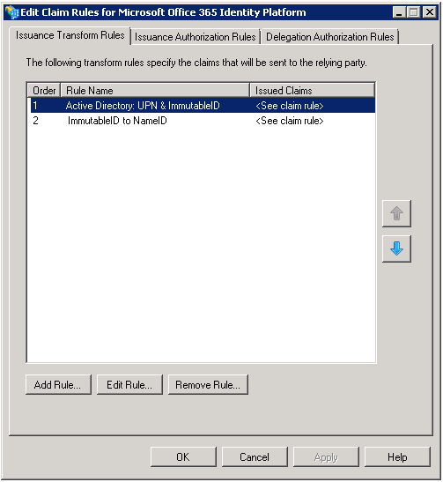
These 2 rules are defined as follows:
- “Active Directory: UPN & ImmutableID” custom rule: By querying Active Directory based on the user logon name, this rule retrieves:
  - The UPN claim: UPN of the user tied to the provisioned value for the user;
  - The ImmutableID claim: Unique, rename-safe identifier of the user tied to provisioning of the user.
This rule enables sourcing the UPN and ImmutableID attribute elements of the attribute statement element in the issued SAML 1.1 logon token as illustrated hereafter.

c:[Type == "http://schemas.microsoft.com/ws/2008/06/identity/claims/windowsaccountname"]
=> issue(store = "Active Directory", types = ("http://schemas.xmlsoap.org/claims/UPN",
"http://schemas.microsoft.com/LiveID/Federation/2008/05/ImmutableID"), query = "samAccountName={0};userPrincipalName,objectGUID;{1}", param = regexreplace(c.Value, "(?<domain>[^\\]+)\\(?<user>.+)", "${user}"), param = c.Value);

- “ImmutableID to NameID” custom rule: As its name indicated, this rule transforms the ImmutableID claim into a SourceID claim.
This rule enables sourcing the subject element of the attribute statement element in the issued SAML 1.1 logon token as illustrated hereafter.

c:[Type == "http://schemas.microsoft.com/LiveID/Federation/2008/05/ImmutableID"]
=> issue(Type = "http://schemas.xmlsoap.org/ws/2005/05/identity/claims/nameidentifier",
Value = c.Value, Properties["http://schemas.xmlsoap.org/ws/2005/05/identity/claimproperties/format"] =
"urn:oasis:names:tc:SAML:1.1:nameid-format:unspecified");

The resulting SAML 1.1 logon token looks as follows. This XML-based signed token is a so-called "bearer" token, a short-lived bearer token (, i.e. without a proof of possession,) that is issued by the AD FS 2.0 federation service to the Office 365 sign-in service.
Such a token includes both an attribute statement and authentication statement:
- Attribute statement: It asserts that the subject identified here by a NameID (ImmutableID) is associated with certain claims (UPN and ImmutableID in our context). Claims are provided as a string name-value pair;
- Authentication statement: It asserts that the security principal, i.e. the subject, has been authenticated by the AD FS 2.0 federation service at a particular time using a particular method of authentication: AuthenticationMethod="urn:oasis:names:tc:SAML:1.0:am:password";
The general syntax and semantics of SAML 1.1 tokens are defined in the core specification of the OASIS SAML standard Assertions and Protocols for the OASIS Security Assertion Markup Language (SAML) V1.1.

<saml:Assertion MajorVersion="1" MinorVersion="1" AssertionID="_55b4b481-da5e-49fa-a8f2-af3198cbd1b3"

Issuer="http://sts.idmgt.demo/adfs/services/trust"

IssueInstant="2012-02-14T15:53:38.976Z"
xmlns:saml="urn:oasis:names:tc:SAML:1.0:assertion">
<saml:Conditions NotBefore="2012-02-14T15:53:38.960Z" NotOnOrAfter="2012-02-14T16:53:38.960Z">
<saml:AudienceRestrictionCondition>
<saml:Audience>urn:federation:MicrosoftOnline</saml:Audience>
</saml:AudienceRestrictionCondition>
</saml:Conditions>
<saml:AttributeStatement>

<saml:Subject>
<saml:NameIdentifier Format="urn:oasis:names:tc:SAML:1.1:nameid-format:unspecified">
jQs1n5IS0EKf4byoSsOr6A==
</saml:NameIdentifier>
<saml:SubjectConfirmation>
<saml:ConfirmationMethod>urn:oasis:names:tc:SAML:1.0:cm:bearer</saml:ConfirmationMethod>
</saml:SubjectConfirmation>
</saml:Subject>
<saml:Attribute AttributeName="UPN" AttributeNamespace="http://schemas.xmlsoap.org/claims">
<saml:AttributeValue>o365a@demo.idmgt.archims.fr</saml:AttributeValue>
</saml:Attribute>
<saml:Attribute AttributeName="ImmutableID"
AttributeNamespace="http://schemas.microsoft.com/LiveID/Federation/2008/05">
<saml:AttributeValue>jQs1n5IS0EKf4byoSsOr6A==</saml:AttributeValue>
</saml:Attribute>

</saml:AttributeStatement>
<saml:AuthenticationStatement AuthenticationMethod="urn:oasis:names:tc:SAML:1.0:am:password"
AuthenticationInstant="2012-02-14T15:53:38.929Z">
<saml:Subject>
<saml:NameIdentifier Format="urn:oasis:names:tc:SAML:1.1:nameid-format:unspecified">
jQs1n5IS0EKf4byoSsOr6A==
</saml:NameIdentifier>
<saml:SubjectConfirmation>
<saml:ConfirmationMethod>urn:oasis:names:tc:SAML:1.0:cm:bearer</saml:ConfirmationMethod>
</saml:SubjectConfirmation>
</saml:Subject>
</saml:AuthenticationStatement>
<ds:Signature xmlns:ds="http://www.w3.org/2000/09/xmldsig#">
<ds:SignedInfo>
<ds:CanonicalizationMethod Algorithm="http://www.w3.org/2001/10/xml-exc-c14n#" />
<ds:SignatureMethod Algorithm="http://www.w3.org/2000/09/xmldsig#rsa-sha1" />
<ds:Reference URI="#_55b4b481-da5e-49fa-a8f2-af3198cbd1b3">
<ds:Transforms>
<ds:Transform Algorithm="http://www.w3.org/2000/09/xmldsig#enveloped-signature" />
<ds:Transform Algorithm="http://www.w3.org/2001/10/xml-exc-c14n#" />
</ds:Transforms>
<ds:DigestMethod Algorithm="http://www.w3.org/2000/09/xmldsig#sha1" />
<ds:DigestValue>hKJnVjG/rq/bdy1RrnztTIiBE6c=</ds:DigestValue>
</ds:Reference>
</ds:SignedInfo>
<ds:SignatureValue>
tT4kMFkVL+l2D6fcD9QhDW+HN+rktCq7lZ9WMsPV+3ONoSq+KH/4qMrO0XncZySYlxMlhLbl7ZAJP5t0eErFbEBfH8+J3PPrsaRU+
mXQe7lfIj1ir1l+hCpbC3Hywnirm01sLaj8NUHnM3/B0KDWblOzpPkOXKvM4Rd4SVsNiKykwp2Em3f80hZWLu2mQRJxiti2n6NcOt
Md4YhOV0fNhH5LHzc0SWNUiIALqtrc7b67YaOFMM21oxQBRffxnY4ns5kRU/aTKCTTwZzamBoRdCI97j0CjT8XTv+LfLHkcWaBH+5
up0Xd+g3T8jTikGQpMDzuvbOtIlY69DUnCIz0DQ==
</ds:SignatureValue>
<KeyInfo xmlns="http://www.w3.org/2000/09/xmldsig#">
<X509Data>
<X509Certificate>
MIIC8DCCAdigAwIBAgIQF1RifzXrH59A+2Jtoe+5ADANBgkqhkiG9w0BAQsFADA0MTIwMAYDVQQDEylBREZTIFNpZ25pbmcgL
SBhZGZzLmRlbW8uaWRtZ3QuYXJjaGltcy5mcjAeFw0xMTA4MTAxOTIyNTZaFw0xMjA4MDkxOTIyNTZaMDQxMjAwBgNVBAMTKU
FERlMgU2lnbmluZyAtIGFkZnMuZGVtby5pZG1ndC5hcmNoaW1zLmZyMIIBIjANBgkqhkiG9w0BAQEFAAOCAQ8AMIIBCgKCAQE
AwNpcxWSMJ3TbXfHEAAa4Moi7+S+k6JypSPq45FHAkyn3QkGzRsjJt9KF05/PvUsudukl+OZxXUHsb1pWMQniZAh5G7h6rUXf
k1eeJhDHgBFpwI5yrLGdUlcGrQxNNE4UCLuDwRWG9WjA6Gr7q3bD68vFom/OitsyK18RRB4kCkFWHTln98b7EDieFQQPDxoRP
o+Od6eQ/sejR6D7zJKW9LByT8H8BBOrm4CD9vpBoHiVxIgciLrARx0oCiayh/oYihZDWI8HYv1TlVd9uh+Rxsax7Qt0dWA/Me
06gOO5THo2YmxVA4wG3sdyl74MjgmPSv2qR6mP4GAGxk4sfK59iQIDAQABMA0GCSqGSIb3DQEBCwUAA4IBAQAxr2UPF+6osSL
mF0bdn+Ysj98Q69c6LVLBmTcnd9VBqoefBtcvQe/rp34f2Ok3nqLVRgQv+aWfQrCwM5/5e93saZpdY2UH/U8cvSb+X2PqBK9y
CPDejAtfjo3sCv0ET+0UkoQirK4/CTn07tg+37teZ1EVHaO3DHiI695llnW7Z7j/LH7TLaIP2l9WY2Fe5D+B0iZlYE9kCTDUq
hVR4037cTKC7RKyl/hBPc1xRtQE0ya0lhb4THZjID4fHv9KYQOGaiUHnETt+Qc12pYnZW66O7KXj1Ap47IStGvWiOMbJ6jm4Y
oGyZRa7MC5Gh2z3AQGZ2Rj1KPW3OQ/T3u3u84k
</X509Certificate>
</X509Data>
</KeyInfo>
</ds:Signature>
</saml:Assertion>

One should note that the Issuer URI, for example http://sts.idmgt.demo/adfs/services/trust, in the above token is used to locate the namespace in the Office 365 sign-in service.

Issuance Authorization Rules
The automated definition of the trust creates a “Permit Access to All Users” rule in the Issuance Authorization Rules set.
This rule that authorizes everyone is defined as follows:

=> issue(Type = "http://schemas.microsoft.com/authorization/claims/permit", Value = "true");

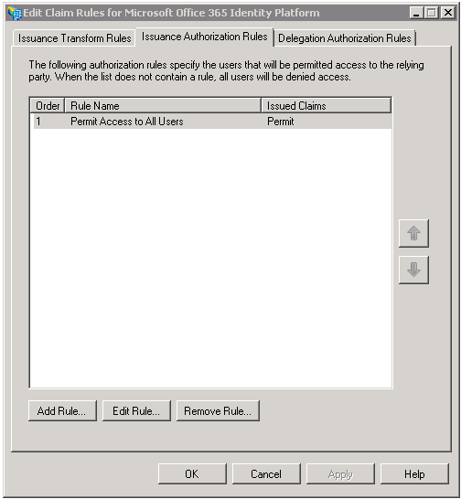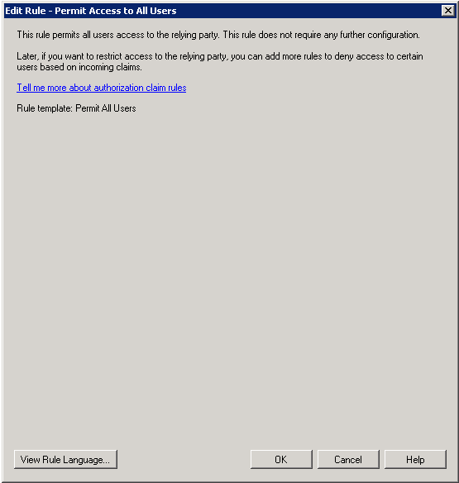

Endpoints
AD FS 2.0 endpoints are used to provide clients with access to federated solutions/applications. Endpoints will issue SAML authentication tokens to clients, after successful client authentication. These endpoints are managed on the federation server(s) (farm) of the AD FS 2.0 federation service, and can be managed, secured and published individually through a (load-balanced) AD FS 2.0 federation server proxy (see section § 2.4.4.1 AD FS 2.0 federation server proxy).
The AD FS 2.0 federation server proxy is a deployment mode of AD FS 2.0 specifically designed for that purpose to provide remote access to the internally-hosted AD FS 2.0 service.
In a typical deployment (see section § 4.2.1.1 Scenario 1 - Fully-implemented AD FS 2.0), the federation server proxy is hosted in a perimeter network, and passes data through port 443 to the FS (farm), which issues the required SAML security token.
The AD FS 2.0 federation server proxy can respond to token requests for accessing AD FS 2.0 relying parties. One should note that, being limited to proxying only the AD FS 2.0 service, the federation server proxy cannot enable access to relying parties hosted inside the corporate firewall without the help of a general-purpose reverse proxy, such as Microsoft Forefront Threat Management Gateway (TMG).
One should note that, in the specific context of this paper, an AD FS 2.0 federation server proxy is required for Exchange Online, as well as for allowing access to SharePoint 2010 Online and Lync Online from outside the internal corporate network as previously outlined. Furthermore, both the AD FS 2.0 federation service inside the corporate network and the AD FS 2.0 federation server proxy should be implemented in a highly available way, as any outage of this infrastructure will prevent access to the federation service.
Figure AD FS 2.0 endpoints
For accessing Office 365 online services, three distinct endpoints must be considered:
- Passive Federation (WS-Fed Passive Profile) endpoint: This endpoint is used by Web clients, when accessing the following services: the Microsoft Online Portal (MOP), the SharePoint Online portals, Outlook Web Apps (OWA).
Web client (browsers) will directly authenticate with the AD FS 2.0 federation service, through this endpoint
Due to a transition to browser based interactions during authentication, this endpoint also applies to Office 2007 Service Pack 2 (SP2) or Office 2010 (Word, Excel or PowerPoint) when opening documents from a SharePoint Online document library. The client will effectively rely on a response from SharePoint Online to popup a browser like dialog window which subsequently support federation-related Web protocols (WS-Fed in this specific context) that rely on redirect schemes.
The authentication flow is that relates to this endpoint is covered in section § 5.2 Understanding the passive/Web profile authentication flow.
- Active Federation (WS-Trust Active Profile) endpoint: This endpoint is used by rich clients supporting AD FS 2.0 and more specifically by Lync 2010 and the Office Subscription client in the context of this paper.
These two clients listed above will negotiate to authenticate directly with the AD FS 2.0 service, through this endpoint. The related authentication flow is further covered in section § 5.3 Understanding the MEX/rich client profile authentication flow.
- EAS Basic Authentication/Active profile endpoint: This endpoint applies to all clients relying on a service to authenticate on-behalf of users, and thus authenticating with Basic Authentication (credential passed over Basic Authentication).
As far as Office 365 is concerned, this endpoint is typically used by Microsoft Exchange 2010 ActiveSync (EAS), Outlook 2007 and 2010, IMAP, POP and SMTP, Exchange 2010 Web Services.
The client sends basic authentication credentials over SSL to Exchange Online and Exchange Online will then proxy this authentication request to the AD FS 2.0 federation service on behalf of the client, through this endpoint. The related authentication flow is further covered in section § 5.4 Understanding the EAS Basic Auth/Active profile authentication flow.
For client access restrictions purpose, these three endpoints can be controlled/filtered at the federation server proxy level (if any according to the adopted implementation scenario, see section § 4.2.1 AD FS 2.0 implementation scenarios for Office 365). Furthermore, filtering via AD FS 2.0 issuance rules is also now supported since October 2011 (see section § 6.3 Limiting Access to Office 365 Services Based on the Location of the Client).
The Get-MsolFederationProperty cmdlet enable to see the current AD FS 2.0 endpoint information.
To view the current settings, proceed as follows:
- Connect Windows PowerShell to the Microsoft Online Services (see section § 4.3.2 Connecting Windows PowerShell to the Microsoft Online Services).
- Run the command Get-MsolFederationProperty –DomainName <domain name>. The following is the output from the above command. This information is extremely useful and can be used to do a quick check to see any issues with the single sign-on configuration.

PS C:\Windows\system32> Get-MSOLFederationProperty -DomainName demo.idmgt.archims.fr
Source : ADFS Server
ActiveClientSignInUrl : https://adfs.demo.idmgt.archims.fr/adfs/services/trust/2005/usernamemixed
FederationServiceDisplayName : ADFS IDMGT MTC Paris
FederationServiceIdentifier : http://sts.idmgt.demo/adfs/services/trust
FederationMetadataUrl : https://adfs.demo.idmgt.archims.fr/adfs/services/trust/mex
PassiveClientSignInUrl : https://adfs.demo.idmgt.archims.fr/adfs/ls/
PassiveClientSignOutUrl : https://adfs.demo.idmgt.archims.fr/adfs/ls/
TokenSigningCertificate : [Subject]
CN=ADFS Signing - adfs.demo.idmgt.archims.fr
[Issuer]
CN=ADFS Signing - adfs.demo.idmgt.archims.fr
[Serial Number]
1754627F35EB1F9F40FB626DA1EFB900
[Not Before]
10/08/2011 21:22:56
[Not After]
09/08/2012 21:22:56
[Thumbprint]
25A70E3841C2614B097587EBDB9BBF0AE00D818C
NextTokenSigningCertificate :
Source : Microsoft Office 365
ActiveClientSignInUrl : https://adfs.demo.idmgt.archims.fr/adfs/services/trust/2005/usernamemixed
FederationServiceDisplayName : ADFS IDMGT MTC Paris
FederationServiceIdentifier : http://sts.idmgt.demo/adfs/services/trust
FederationMetadataUrl : https://adfs.demo.idmgt.archims.fr/adfs/services/trust/mex
PassiveClientSignInUrl : https://adfs.demo.idmgt.archims.fr/adfs/ls/
PassiveClientSignOutUrl : https://adfs.demo.idmgt.archims.fr/adfs/ls/
TokenSigningCertificate : [Subject]
CN=ADFS Signing - adfs.demo.idmgt.archims.fr
[Issuer]
CN=ADFS Signing - adfs.demo.idmgt.archims.fr
[Serial Number]
1754627F35EB1F9F40FB626DA1EFB900
[Not Before]
10/08/2011 21:22:56
[Not After]
09/08/2012 21:22:56
[Thumbprint]
25A70E3841C2614B097587EBDB9BBF0AE00D818C
NextTokenSigningCertificate :

This shows the AD FS 2.0 federation service endpoint information:
- The Passive Federation (WS-Fed Passive Profile) endpoint is the adfs/ls/ endpoint, which corresponds to the PassiveClientSignInUrl entry;
- The Active Federation (WS-Trust Active Profile) endpoint is the /adfs/services/trust/mex/ endpoint, which corresponds to the FederationMetadataUrl entry.
- The EAS Basic Authentication/Active profile endpoint is the /adfs/services/trust/2005/usernamemixed endpoint, which corresponds to the ActiveClientSignInUrl entry.
If, for some reason, a client is hitting the wrong endpoint, this command can be run to assist in determining why.
In terms of troubleshooting, and as further described in the next sections, the authentication flow of any Office 365 single sign-on communication is predictable. The expected authentication flow pattern can be compared to or contrasted with a capture of the actual authentication flow that occurs during a failing single sign-on attempt to determine what might be wrong with the process.
The AD FS Authentication Diagnostic part of the Microsoft Online Services Diagnostics and Logging (MOSDAL) Support Toolkit 4.0 can perform such capture and comparison in order to troubleshoot passive/active federated authentication issues with Office 365 by:
- Detecting if the machine is on the corporate network or on the Internet;
- Verifying the Office 365 registration;
- Verifying that the MEX/Federation metadata can be retrieved from the AD FS 2.0 federation service;
- Doing active/passive login to Office 365 using the AD FS 2.0 issued logon token.
To run MOSDAL to test passive/active single sign-on, proceed as follows:
- Download the .msi package from the Microsoft Download Center and install it.
- Launch the MOSDAL Support Toolkit.
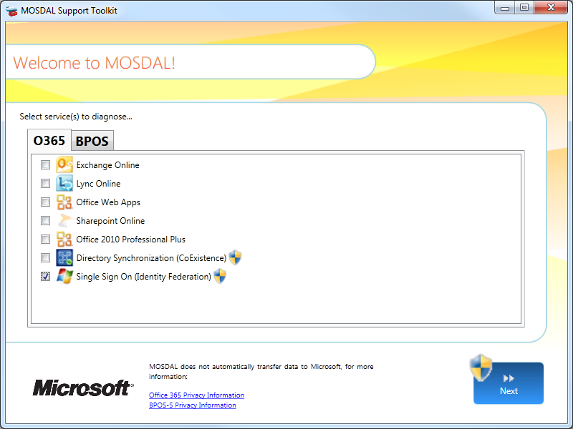
- In the O365 tab, select Single Sign On (Identity Federation) and click Next.
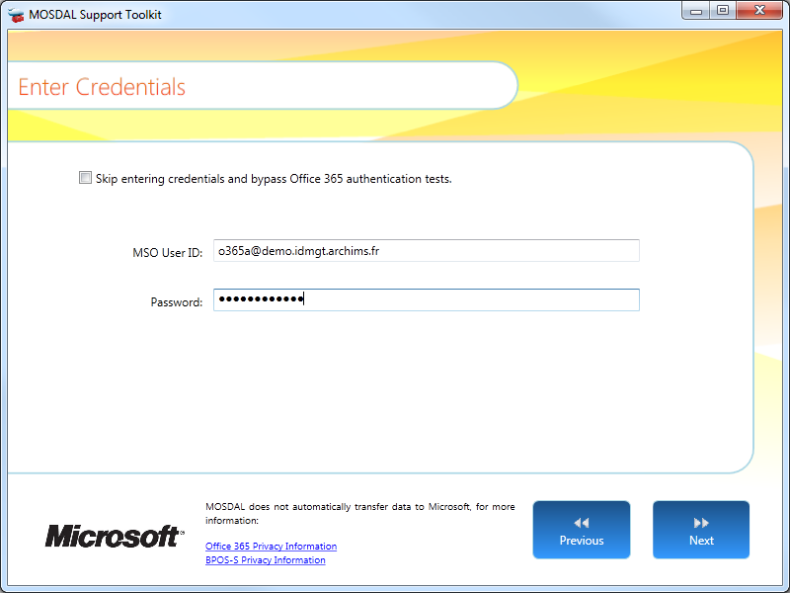
- Enter your credentials and click Next.
- Click Next to start running the diagnostics.
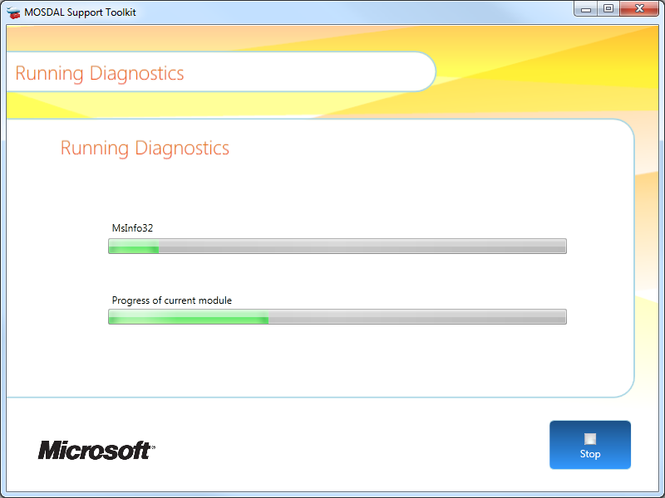
Similarly, the Microsoft Remote Connectivity Analyzer (RCA) can be used to diagnose Office 365 passive single sign-on issues.
To run RCA to test single sign-on, proceed as follows:
- Open a Web browser, and then navigate to https://testexchangeconnectivity.com.
- Click the Office 365 tab.
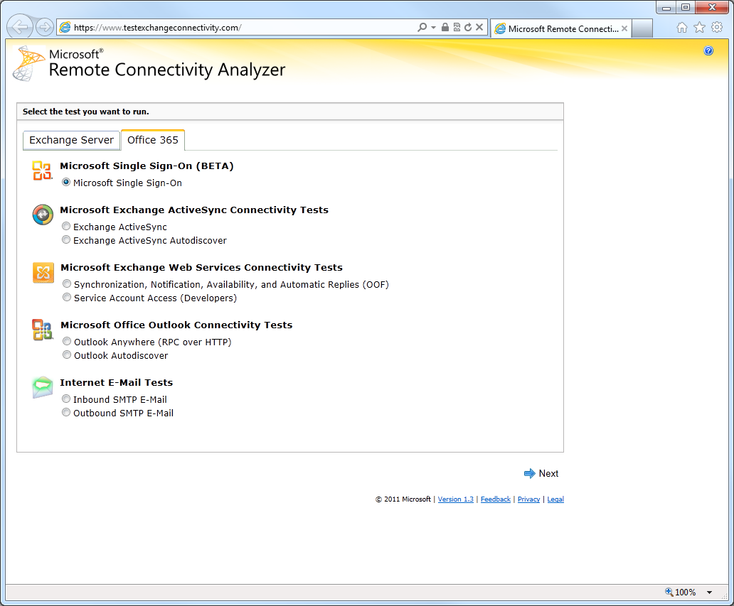
- Select Microsoft Single Sign-On, and then click Next.
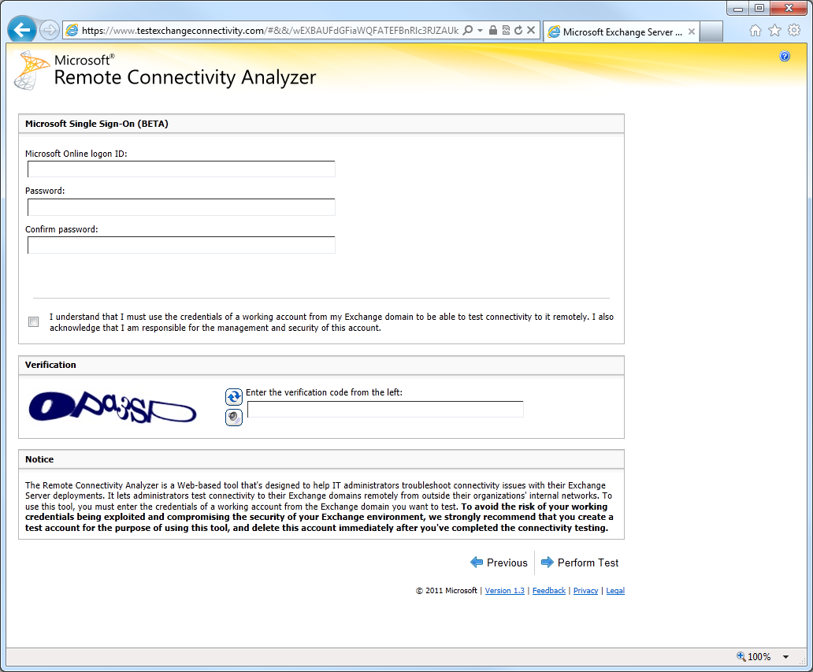
- Type your on-premise corporate UPN and the password, check the security acknowledgement check box, type the verification code, and then click Perform Test.
The AD FS 2.0 Troubleshooting Guide can be used in conjunction to resolve the issue if any.

Understanding the passive/Web profile authentication flow
In the schema below, the user tries to access a Web-based Office 365 service like SharePoint Online or Outlook Web Apps (OWA) from a browser from its domain joined work computer connected to the corporate network.
When authenticating to Office 365, Internet browsers will establish a connection to the organization’s AD FS 2.0 federation service, to request a SAML 1.1 logon token.
Authentication to the AD FS federation service take place using Integrated Windows Authentication (Kerberos or NTLMv2), and doesn’t require any user interaction or prompting. The logon token is presented to the Office 365 sign-in service, granting access to the Office 365 service.
Figure Passive/Web profile authentication flow
The passive profile authentication flow is the following:
- The user hits the Web-based Office 365 service. The service tells the client that it needs an authentication token signed by the Office 365 sign-in service, and returns the sign-in service URL of the Office 365 Identity Platform via a HTTP 302 redirected in order to go get a ticket from there.
- The client goes to the Office 365 sign-in service asking for an authentication token. The sign-in service takes the UPN the user types in and then knows if it is a federated domain. It then says it can’t sign you in; it needs a logon token signed by your on-premise claims provider, i.e. the on-premise AD FS 2.0 federation service. So it returns the AD FS 2.0 federation service passive federation endpoint URL (adfs/ls/) via a HTTP 302 redirected.
- The client goes to the AD FS 2.0 federation service to request a logon token. The AD FS 2.0 federation service asks to user to authenticate (via Integrated Windows Authentication by default in this configuration) against the on-premise Active Directory, and after a successful authentication, queries the on-premise Active Directory to retrieve the user claims, and then issues a SAML 1.1 token containing the claims about the logged in user, i.e. its UPN and its Source ID (ImmutableID), which it then signs with the currently declared X.509 token signing certificate.
- The client presents via a HTTP POST this signed SAML 1.1 logon token to the Office 365 sign-in service. The sign-in service checks that the incoming token is indeed signed by the trusted claims provider for the federated domain through the public key of the X.509 signing certificate that was shared during the trust establishment via the exposed metadata. It then transforms the Source ID into an internal unique identifier (Unique ID) from the Office 365 Identity Platform, and then issues a new token with the UPN and the Unique ID, which it signs. This forms the authentication token.
- The authentication token gets back to the client and the client presents the authentication token to the Web-based Office 365 relying party service. The relying party service opens the token, checking that it is signed by the trusted claims provider, i.e. the Office 365 Identity Platform), based on a shared public key. It looks at the Unique ID claim and searches for a user in its directory with that Unique ID. (The Unique ID is set as part of provisioning/creating the user, and synchronized to the service.) Once found, the service can apply the necessary access control checks before allowing the user access to the intended Web-based Office 365 service.
The process sounds fairly complicated but when broken down you can see how the process actually works. If there had been an issue here it would be easy to determine at least were to start troubleshooting.
For additional information, you can refer to the article How Single Sign-On Works in Office 365. From a protocol perspective, further details are provided in the chapter § 13 Web (Passive) Requestors of the OASIS WS-Federation (WS-Fed) specification. If you want to the capture the flow, you can use the network trace application or the Fiddler tool (with Fiddler Inspector for Federation Messages. For the latter, please refer to the article AD FS 2.0: How to Use Fiddler Web Debugger to Analyze a WS-Federation Passive Sign-In.

Understanding the MEX/rich client profile authentication flow
Figure MEX/rich client profile authentication flow
In the above schema, the user tries to access Lync Online from its domain joined work computer. The active profile authentication flow is the following:
- The user logs on to his domain joined work computer on the corporate network. After a successful logon, the client MSOIDSVC service, i.e. the Microsoft Online Services Sign-In Assistant (MOS SIA) service (see section § 3.1.2 Work computer requirements) kicks in and gets the logged on user’s Active Directory domain by looking at the domain suffix of his UPN. The MSOIDSVC service calls a home realm discovery (HRD) service on the sign-in service of Office 365 Identity Platform.
The sign-in service checks to see if that domain is a registered federated domain. If not, it returns nothing; if it is, the sign-in service returns the metadata exchange endpoint (MEX endpoint) URL of the registered federation server, i.e. the organization’s on-premise AD FS 2.0 federation service.
- If nothing is returned, the MSOIDSVC service is done. If a MEX endpoint URL is returned, the MSOIDSVC service contacts the MEX endpoint (/adfs/services/trust/mex/) of the federation service, which returns a list of WS-Trust endpoints exposed by the federation service.
- The MSOIDSVC service chooses the most appropriate authentication endpoint type (for Integrated Windows Authentication (Kerberos or NTLMv2)) in order to request a SAML 1.1 logon token. It then goes to the chosen authentication endpoint and authenticates via Kerberos or NTLMv2. Once authenticated, the federation service gets the logged on user’s NTLMv2 token or Kerberos ticket, queries the on-premise Active Directory to retrieve for the user claims, and then issues a SAML 1.1 logon token containing the claims about the logged in user, i.e. its UPN and its Source ID (ImmutableID), which it then signs with the currently declared X.509 token signing certificate. The logon token is returned to the MSOIDSVC service.
- The MSOIDSVC service now requests an authentication token from the Office 365 sign-in service, providing the SAML 1.1 logon token it received from the AD FS 2.0 federation service.
The Office 365 sign-in service verifies the incoming logon token, transforms the Source ID into an internal unique identifier (Unique ID) from the Office 365 Identity Platform, and then issues a new authentication token (containing the UPN and the Unique ID claims), which is then sent back to the client. This authentication token can now be used for login. Please note that all the above happen transparently at logon and the user doesn’t see it.
The MSOIDSVC service now caches this token ready for use by the client applications.
- The user now starts up Lync 2010. Lync 2010 attempts to connect to Lync Online, which requests an authentication token.
- Lync 2010 (via an in-process call to the MSOIDCLI.dll) requests an authentication ticket from the MSOIDSVC service. The service has already got one and sends it to Lync Online. Lync Online processes the token and applies the necessary access control checks before allowing the user access to the service.

Understanding the EAS Basic Auth/Active profile authentication flow
In the schema below, the user opens up Outlook from its domain joined work computer. When authenticating to Exchange Online, Outlook is using Basic Authentication credentials against Office 365, in an encrypted form. The Office 365 platform establishes in turn a connection to the organization’s AD FS 2.0 federation service to request a SAML logon token, granting user access to the Office 365 service.
Figure EAS Basic Authentication/Active profile authentication flow
The Exchange ActiveSync (EAS) Basic Authentication/Active profile authentication flow is the following:
- The user logs on to his domain joined work computer on the corporate network (and the MSOIDSVC service do the round trip to get the SAML 1.1 authentication token and then to cache it). The user now starts up Outlook 2010.
Outlook attempts to connect to Exchange Online (via Integrated Windows Authentication and the SSPI layer using Negotiate), but Exchange Online challenges for Basic Authentication.
- The user will get a prompt the first time and will need to type in his corporate credentials, i.e. his username in the form of the UPN and his password. The user can save them, and will not be prompted again until his password changes. This will be sent off by Outlook to Exchange Online.
- Exchange Online now does a trick called “Proxy Auth” where it creates a shadow representation of the user. It then takes the domain/UPN from the Basic Authentication and sends it to the Office 365 sign-in service.
The Office 365 Identity Platform returns with the active profile endpoint URL (/adfs/services/trust/2005/usernamemixed) of the organization‘s on-premise AD FS 2.0 federation service.
- Exchange Online then takes the basic authentication credentials and sends them to the active profile endpoint of the federation service.
The federation service authenticates the user with the basic credentials against the on-premise Active Directory, query the on-premise Active Directory to retrieve for the user claims, and then issues a SAML 1.1 logon token (containing the UPN and the Source ID (ImmutableID) claims about the user), which it then signs with the currently declared X.509 token signing certificate. This comes back to Exchange Online.
- Exchange Online sends it to the Office 365 sign-in service. The sign-in service verifies the logon token and converts it to an authentication token, which contains the UPN and the internal unique identifier (Unique ID) from the Office 365 Identity Platform). This authentication token can now be used for login.
Exchange Online can now authenticate the user with the authentication token and will delete the shadow representation of the user.
It should be noted that customer credentials aren’t persisted anywhere in the above authentication legs, and customer credentials aren’t stored or cached in Microsoft datacenters.
Furthermore, as mentioned below, in order to avoid being prompted for their credentials at each new Outlook session, users can choose to have their credentials cached in the Windows Credential Manager, by selecting the Save Password option in the Outlook password prompt.
The Windows Credential Manager provides a secure area (vault) for storing user credentials, allowing easier access to remote services. The stored passwords can be protected at multiple levels:
- For domain-joined machines, the user password needs to be known to get access to the Credential Manager content;
- Concerns about stolen hard disks can be mitigated through the deployment of disk encryption technologies such as Bit locker on Windows 7;
- Home workstations and other unmanaged clients may pose a greater risk if passwords are cached locally. Customers can implement Client Access Policies (see section § 6.3.2 Using the Client Access Policy) to prevent connection to their Office 365 services from outside of their network, thus mitigating the risk of employees caching corporate passwords on unmanaged clients.

Some information you should be aware of
This section provides information you should be aware of regarding the single sign-on. You can also refer to the article Configuring Advanced Options for AD FS 2.0 and Office 365.

Supporting Multiple Top Level Domains
Until the first availability of the Update Rollup 1 for AD FS 2.0, organizations that leverage the single sign-on capability through AD FS 2.0 and that have multiple top level domains for user's UPN suffixes within their organization (for example, @idmgt.fr or @idmgt.co.uk) were required to deploy a separate instance of the AD FS 2.0 federation service for each suffix.
After installing the Update Rollup 2 (or the previous Update Rollup 1) on all the AD FS 2.0 federation servers and follow the instructions of using this feature with Office 365, new claim rules will be set to dynamically generate token issuer IDs based on the UPN suffixes of the users.
As a result, you do not have to set up multiple instances of AD FS 2.0 federation service to support single sign-on for multiple top level domains (without sub domains) in Office 365. This requires the use of the new switch SupportMultipleDomain with the Microsoft Online Services Module for Windows PowerShell.
Important note:
This switch is not required when you have a single top level domain and multiple sub domains. For example if the domains used for the UPN suffixes are @legal.idmgt.fr, @paris.idmgt.fr and @idmgt.fr and the top level domain (idmgt.fr in this case) was added first and federated then you don’t need to use the SupportMultipleDomain switch. This is because these sub domains are effectively managed within the scope of the parent and a single AD FS 2.0 federation service can be utilized to handle this.

If you have multiple top level domains (@idmgt.fr and @ idmgt.co.uk) and these domains also have sub domains (@paris.idmgt.fr and @london.idmgt.co.uk), the SupportMultipleDomain switch will not work for the sub domains and these users will not be able to login. This issue relates to the fact that the Issuer URI in the issued logon token by the AD FS 2.0 federation service is used to locate the namespace in the Office 365 sign-in service.
One possible approach consists in configuring a regular expression in the issuance transform rules of the Office 365 Identity Platform relying party trust (see section § 5.1.4.2 Issuance Transform Rules) to truncate domain name for the Issuer URI:

c:[Type == "http://schemas.xmlsoap.org/claims/UPN"]
=> issue(Type = "http://schemas.microsoft.com/ws/2008/06/identity/claims/issuerid",
Value = regexreplace(c.Value, ".+@(?<domain>.+)", "http://${domain}/adfs/services/trust/"));

Additional information is provided in the article Support for Multiple Top Level Domains.

Supporting Strong Authentication (2FA) for Office 365
The AD FS 2.0 federation service, i.e. typically an AD FS 2.0 federation server farm (see section § 4.2.1.1 Scenario 1 - Fully-implemented AD FS 2.0), sits inside the corporate network and authenticates corporate users on the internal network using by default Integrated Windows Authentication (IWA).
However, it is increasingly common for corporate users to need access to their usual resources like the services in Office 365 that reside in the cloud at times when they themselves are remote, at home, at the airport, at an Internet café, etc.
In order to benefit from single sign-on capabilities that are discussed throughout this paper, these users must be able to access the AD FS 2.0 federation service so that they can request authentication tokens to access the available services as needed.
To address situations like these and to consequently make the AD FS 2.0 federation service remotely accessible for their users, organizations leverage in this context the network perimeter as an access control edge via the AD FS 2.0 federation server proxy, a deployment mode of AD FS 2.0 specifically designed for that purpose to provide remote access to the internally-hosted AD FS 2.0 federation service and to consequently allow proxied access to necessary services in Office 365.
Note:
Alternative proxies can be used to expose from the outside of the corporate network the AD FS 2.0 federation service as described in section § 2.4.4.2 Alternative proxies. The rest of this section focuses on AD FS 2.0 federation server proxy.

This is managed in the organization’s (on-premise) infrastructure and does not require specific caution.
Organizations allowing such remote access commonly consider strong authentication techniques to secure inbound access. Since attackers can reach the inbound access point easily, and successful authentication to a federation server farm potentially grants the attacker access to security tokens for numerous relying parties, thus securing remote authentication is important.
Strong authentication or Two-factor authentication (2FA) provides improved security because it requires the user to meet two authentication criteria, for instance “something you know” (a user name/password) combined with “something you have” (a token or certificate).
Enabling strong authentication for Web clients outside the organization network is supported with Office 365.
2FA support is not available for clients other than Web browsers. Outlook 2010, Lync 2010, ActiveSync, and other rich clients do not have the capability to prompt users for strong authentication credentials and therefore cannot be supported.
However, there are some exceptions to this rule due to a transition to browser based interactions during authentication. Indeed, when an Office 2007 Service Pack 2 (SP2) or Office 2010 client (Word, Excel or PowerPoint) attempts to access a SharePoint Online document library, the client will rely on a response from SharePoint Online to popup a browser-like dialog window which subsequently supports federation-related Web protocols (WS-Federation) that rely on redirect schemes.
In this scenario, strong authentication is achieved by configuring the federation server proxy to require 2FA for the “Passive Federation” endpoint (see section § 5.2 Understanding the passive/Web profile authentication flow).
Important note:
Strong authentication must only be applied to the “Passive federation” endpoint, as other clients will otherwise not be able to connect.

This is managed in the organization’s (on-premise) infrastructure and does not require specific configuration on the Office 365 Online Services. For that purposes, organizations will need their own 2FA infrastructure being deployed (if any).
Enforcing 2FA authentication with single sign-on for users accessing the above Office 365 Web applications outside the corporate network is implemented by the organization at the proxy level. This also applies to the Office 2007 Service Pack 2 (SP2) or Office 2010 clients (Word, Excel or PowerPoint). However, as already noticed, other rich client applications for Office 365 (Outlook, Lync, etc.) are currently not supported.
Regarding the AD FS 2.0 federation server proxy, following sign-in methods are available in order to collect and process 2FA credentials depending on the supported capabilities of the (3rd party) 2FA solution provider being used:
- Smartcard-based sign-in using AD FS 2.0;
- Forms-based sign-in using a 3rd party 2FA solution provider IIS HTTP module;
- Forms-based sign-in using a customized AD FS 2.0 login page to interact with the 2FA solution provider.
When a federation server proxy (or an AD FS 2.0 federation server) is installed, an ASP.NET Web application, called the Sign-In Pages, is deployed onto the same server to handle passive federation requests.
The Sign-In Pages Web application run in Internet Information Services (IIS), and the related pages are located in %SystemRoot%\Inetpub\adfs\ls and deployed under the /adfs/ls virtual directory of the Default Web site in IIS.
The Sign-In Pages handle notably the WS-Federation protocol and expose extensibility points that allow performing various customizations, and particularly the ability to customize the behavior of forms-based authentication (FBA).
Note:
For additional information related to the customization of AD FS 2.0 Sign-In Pages, you can refer to the page AD FS 2.0 Sign-In Pages Customization Overview in the AD FS 2.0 SDK documentation.

Smartcard-based sign-in using AD FS 2.0
This method has built-in support for smartcard based authentication. When using smartcards, the AD FS 2.0 federation service can project a strong authentication claim to downstream applications and services which can perform further authorization based on the strength of authentication.

Forms-based sign-in using a 3rd party 2FA solution provider IIS HTTP module
This method assumes that the 3rd party 2FA solution supports an Internet Information Services (IIS) HTTP module that is compatible with the IIS version used in Windows Server 2008 or Windows Server 2008 R2 and that it is installed on each of the AD FS 2.0 federation server proxies in your organization. Once the module has been installed and configured on the proxies, it will essentially intercept any traffic destined for the proxy URL’s.
Although, this method does not require much forms-based customization and is typically easy to set up, the end user experience is not optimal because there will be multiple redirects and at least two different prompts for credentials as described in the 2FA authentication process steps below.
- Prior to letting the intercepted traffic through, the module will redirect the browser to the 2FA solution where the end user will provide their 2FA credentials that will be validated with the 2FA service;
- After successful authentication to the 2FA solution, the module will allow the traffic through to be handled by the AD FS 2.0 federation server proxy by redirecting the browser back to the federation server proxy login page;
- While on this page, the end user must provide their corporate Active Directory credentials before they will be authenticated to the Office 365 Web application.
The article AD FS 2.0 Step-by-Step Guide: Integration with RSA SecurID in the Extranet illustrates this method with the RSA Authentication Agent 7.0 for Web for IIS and RSA SecurID tokens.
This method does not require much customization and should be easy to setup. The disadvantage in this approach resides in the end user experience to go through multiple redirects with credential collection at 2 places.

Forms-based sign-in using a customized AD FS 2.0 login page
This method assumes that the 3rd party 2FA solution provider supports an interface that can be called from code that runs behind the federation server proxies customized forms-based login page. The customized forms-based login page typically introduces extra fields for the users to enter extra factors for authentication or extra logic to collect them seamlessly.
As an illustration, you can leverage the Login People Digital DNA Technology, and consequently enable customers to use strong authentication based on "What they know" (a password) and on "What they own" (their computer, smartphone, and/or USB key for example), and thus creating a second authentication factor, in order to reach a high level of security to protect both identities and privacy while realizing the full interoperability potential of AD FS 2.0. The integration with this 3rd party 2FA solution provider is further depicted in the white paper Integrating Login People Digital DNA Server with AD FS 2.0 for interoperable federated Single Sign-On.
Although such method has a more optimal user experience (only one forms-based login page used for both 2FA and Active Directory credentials credentials) than the previous method described above, it requires more administrative effort to set up because you will need to customize the forms-based login page on each of the federation server proxies in your organization so that it can collect both the 2FA credentials and the corporate Active Directory credentials.

Limiting Access to Office 365 Services Based on the Location of the Client
You may want to control the services in Office 365 that will be published to Internet and consequently block some external access scenarios.

Using AD FS 2.0 endpoints
Client access to the service can be controlled through publishing of the AD FS 2.0 endpoints (see section § 5.1.5 Endpoints).
For example, by not publishing the Passive Federation endpoint, an organization can prevent Web clients to connect to the service from outside their corporate network.
Important note:
As previously noticed, to allow Basic Authentication clients to connect (including Outlook 2010), an AD FS 2.0 federation server proxy must be deployed in any case. If a federation server proxy is not available, no Outlook 2010 clients will be able to authenticate, not even from the internal company network.

Using the Client Access Policy
Supported with Office 365 since October 2011, the Client Access Policy, which requires the Update Rollup 2 for AD FS 2.0 (or the previous Update Rollup 1 for AD FS 2.0), is provided for the services in the Office 365, via a three-part solution:
- Through the authentication request attributes that provide information about the clients that are connecting. The AD FS 2.0 federation server proxy will pass five new request context HTTP headers to the AD FS 2.0 federation service:
- x-ms-forwarded-client-ip;
- x-ms-client-application;
- x-ms-client-user-agent;
- x-ms-proxy;
- x-ms-endpoint-absolute-path.
Important note:
If you are using a third-party proxy as per the firewall-published AD FS 2.0 implementation scenario (see section § 4.2.1.2), it must be configured to send the HTTP header x-ms-proxy and it should include the value of the fully qualified DNS name of the proxy host.

- To consume this additional request context information, client access policy introduces a set of new request context claim types:
- http://schemas.microsoft.com/2012/01/requestcontext/claims/x-ms-forwarded-client-ip;
- http://schemas.microsoft.com/2012/01/requestcontext/claims/x-ms-client-application;
- http://schemas.microsoft.com/2012/01/requestcontext/claims/x-ms-client-user-agent;
- http://schemas.microsoft.com/2012/01/requestcontext/claims/x-ms-proxy;
- http://schemas.microsoft.com/2012/01/requestcontext/claims/x-ms-endpoint-absolute-path.
On that basis, a custom acceptance transform rule for each of the new request context claim types must be added on the Active Directory claims provider trust (see section § 5.1.3 On-premise Active Directory Claims Provider Trust) in order to make the new claim types available to the policy engine.
For instance, the following pass-through claim rule has to be created for the request context claim type http://schemas.microsoft.com/2012/01/requestcontext/claims/x-ms-forwarded-client-ip:

c:[Type == "http://schemas.microsoft.com/2012/01/requestcontext/claims/x-ms-forwarded-client-ip"] => issue(claim = c);
Similar additional pass-through claim rules must be created for each of the remaining four claim types.
- AD FS 2.0 can then leverages the new request context claims in the claims pipeline and, more specifically, can act upon them through relevant custom rules defined in the Issuance Authorization Rules set of the Office 365 Identity Platform relying party trust (see section § 5.1.4.3 Issuance Authorization Rules).
The AD FS 2.0 federation service can support access policies for allowing or denying access based upon the combination of the user requesting access, the IP address of his devices, and the access method as documented in the Microsoft TechNet article Limiting Access to Office 365 Services Based on the Location of the Client.
Such a solution enables the following scenarios:
- Block all external access to Office 365: Office 365 access is allowed from all clients on the internal corporate network, but requests from external clients are denied based on the IP address of the external client.
- Block all external access to Office 365, except Exchange ActiveSync (EAS): Office 365 access is allowed from all clients on the internal corporate network, as well as from any external client devices, such as smart phones, that make use of EAS. All other external clients are blocked.
- Block all external access to Office 365, except for browser-based applications such as SharePoint Online or Outlook Web App (OWA): Blocks external access to Office 365, except for Office 365 Web-based services.
- Block all external access to Office 365 for members of designated Active Directory groups: This scenario is used for testing and validating client access policy deployment. It blocks external access to Office 365 only for members of one or more Active Directory group. It can also be used to provide external access only to members of a group.
The Client Access Policy Builder tool aims at configuring these custom AD FS 2.0 client access policies easier and more efficiently.
To configure custom AD FS 2.0 client access policies with the tool, proceed as follows:
- Download the tool from the online gallery and save the file Office_365_-_Client_Access_Policy_Builder.ps1 onto the Desktop.
- Right-click the newly created file Office_365_-_Client_Access_Policy_Builder.ps1, click Properties, click Unblock in the General tab, and click OK.
- Right-click Office_365_-_Client_Access_Policy_Builder.ps1 and click Run with PowerShell.
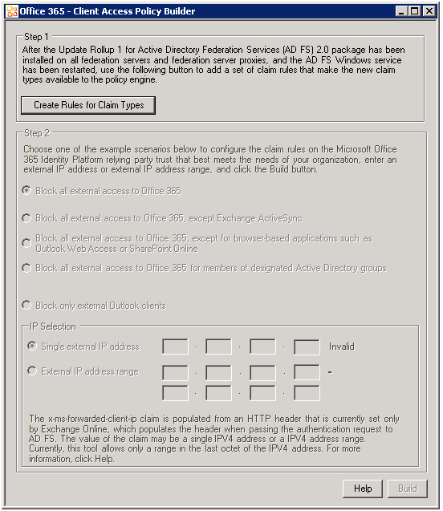
- Click Create Rules for Claim Types to create the five pass-through claim rules on the Active Directory claims provider trust.
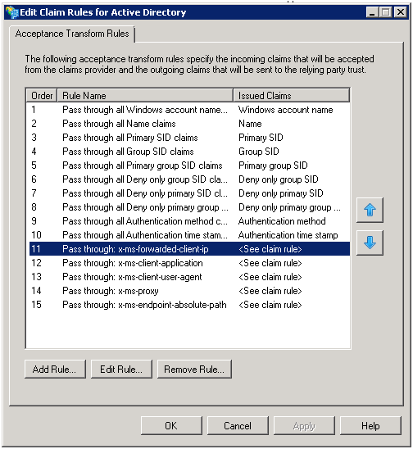
If the tool detects the presence of existing client access policy pass-through rules, it will not take any action, and this will be reflected in the interface.
- Once Step 1 of the Office 365 - Client Access Policy Builder is complete, the interface unlocks the Step 2 portion of the interface.
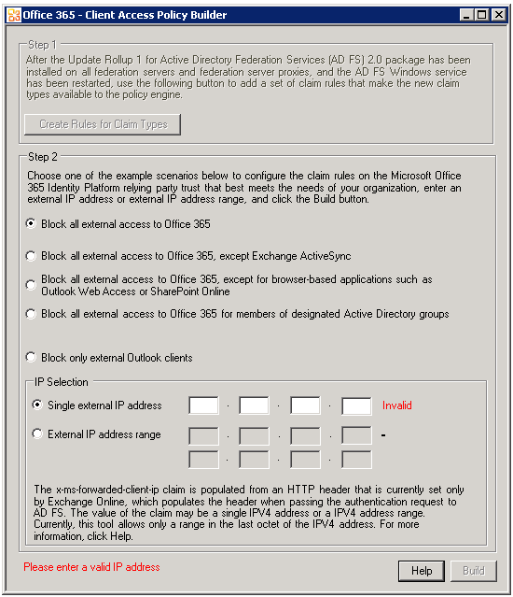
- Select a desired client access policy scenario from the radio button list.
- Enter the external IP address for your environment next to Single external IP address. If you use an external IP address range, you could choose External IP address range and specify the range in the Office 365 - Client Access Policy Builder tool.
- Once you have selected the desired scenario and entered a valid external IP address, click the Build button to generate claim rules for your Office 365 Identity Platform relying party trust.

Using Smart Links for Office 365
Smart links for Office ease the access to Office 365 workloads with federated identities. Smart links are pre-formatted links that work with the following Web passive workloads, i.e. Microsoft Online Portal (MOP), Outlook Web Access (OWA), and SharePoint Online (SPO).
The reason for using pre-formatted links is to simplify the sign-in process for federated users. When a user authenticates to these Office 35 workloads, the default behavior requires the user to enter his UPN at the login.microsoftonline.com prompt to trigger the home realm discovery (HRD) process before redirecting the user to his on-premise AD FS 2.0 federation service (see section § 4.4 Verifying the single sign-on).
If you rather prefer a completely transparent single sign-on experience from on-premise domain-joined work computers, you can deploy and use customized smart links to bypass the home realm discovery prompt.
The article Using smart links or IdP initiated authentication with Office 365 depicts how to adequately customize the smart links in accordance to your Office 365 services.
To sign in to the Microsoft Online Portal (MOP), you can use the following smart links:
https://adfs.demo.idmgt.archims.fr/adfs/ls/?wa=wsignin1.0&wtrealm=urn:federation:MicrosoftOnline
-or-
https://login.microsoftonline.com/login.srf?wa=wsignin1.0&whr=demo.idmgt.archims.fr&wreply=https:%2f%2fportal.microsoftonline.com%2fdefault.aspx
To sign in to Outlook Web Access (OWA), you can use the following smart links:
https://outlook.com/owa/o365a@demo.idmgt.archims.fr
-or-
https://login.microsoftonline.com/login.srf?wa=wsignin1.0&whr=demo.idmgt.archims.fr&wreply=https:%2f%2foutlook.com%2fowa%2fo365a40demo%2eidmgt%2earchims%2efr%2f?exsvurl=1&ll-cc=en-US
To sign in to SharePoint Online (SPO), you can use the following smart link:
https://login.microsoftonline.com/login.srf?wa=wsignin1.0&whr=demo.idmgt.archims.fr&wreply=https:%2f%2fidmgt%2esharepoint%2ecom%2f%5fforms%2fdefault%2easpx
Replace in the above smart links the parts outlined in yellow with the appropriate values of the AD FS 2.0 federation service passive federation public endpoint, the federated domain or the user’s UPN to accommodate your own configuration.
The query string parameters are detailed in OASIS WS-Federation (WS-Fed) specification (see chapter § 13 Web (Passive) Requestors).

Microsoft Office 365: http://office365.microsoft.com/
Office 365 Help: http://onlinehelp.microsoft.com/en-us/office365-enterprises/
Office 365 Deployment Guide for Enterprises: http://www.microsoft.com/download/en/details.aspx?id=26509
Office 365 Tech Center web site: http://technet.microsoft.com/en-us/office365/default
Office 365 Community web site: http://community.office365.com/en-us/default.aspx
Web Services Federation Language (WS-Federation) Version 1.2 : http://docs.oasis-open.org/wsfed/federation/v1.2/ws-federation.pdf
WS-Trust Version 1.3: http://docs.oasis-open.org/ws-sx/ws-trust/200512/ws-trust-1.3-os.pdf
Security Assertion Markup Language (SAML) 2.0: http://go.microsoft.com/fwlink/?LinkId=193996
Microsoft AD FS 2.0 Release to Web (RTW) download: http://www.microsoft.com/downloads/details.aspx?FamilyID=118c3588-9070-426a-b655-6cec0a92c10b
Microsoft AD FS 2.0 download: http://www.microsoft.com/downloads/details.aspx?FamilyID=118c3588-9070-426a-b655-6cec0a92c10b
Identity federation definition from Wikipedia: http://en.wikipedia.org/wiki/Federated_identity
Microsoft Office 365: Identity and Access Solutions: http://channel9.msdn.com/Events/TechEd/NorthAmerica/2011/OSP215
Active Directory synchronization: Roadmap: http://onlinehelp.microsoft.com/en-us/office365-enterprises/ff652543.aspx
Manage directory synchronization: http://onlinehelp.microsoft.com/en-us/office365-enterprises/ff652533.aspx
Plan for and deploy Active Directory Federation Services 2.0 for use with single sign-on: http://onlinehelp.microsoft.com/en-us/office365-enterprises/ff652539.aspx
Single Sign-On FAQ: http://community.office365.com/en-us/w/sso/295.aspx
Office 365 SSO content map: http://community.office365.com/en-us/w/sso/office-365-sso-content-map.aspx
Office 365 Virtual Labs for IT Pros: http://technet.microsoft.com/en-us/office365/hh699847
Microsoft Technology Centers: http://microsoft.com/mtc
Microsoft Windows Azure platform: http://www.windowsazure.com/
Microsoft Office 365: http://office365.microsoft.com/
Active Directory Federation Services 2.0 RTW: http://www.microsoft.com/download/en/details.aspx?displaylang=en&id=10909
Article 2607496 Description of Update Rollup 1 for Active Directory Federation Services (AD FS) 2.0: http://support.microsoft.com/kb/2607496
Article 2681584 Description of Update Rollup 2 for Active Directory Federation Services (AD FS) 2.0: http://support.microsoft.com/kb/2681584
OASIS Security Services (SAML) Technical Committee (TC): http://www.oasis-open.org/committees/tc_home.php?wg_abbrev=security
Understanding Key Concepts Before You Deploy AD FS 2.0: http://technet.microsoft.com/en-us/library/ee913566(WS.10).aspx
Web Services Federation Language (WS-Federation) Version 1.2 : http://docs.oasis-open.org/wsfed/federation/v1.2/ws-federation.pdf
Security Assertion Markup Language (SAML) 2.0: http://go.microsoft.com/fwlink/?LinkId=193996
Using AD FS 2.0 for interoperable SAML 2.0-based federated Web Single Sign-On: http://download.microsoft.com/documents/France/Interop/2010/Using_ADFS2_0_For_Interoperable_SAML_2_0-Based_Federated_SSO.docx
Assertions and Protocol for the OASIS Security Assertion Markup Language (SAML) V1.1: http://www.oasis-open.org/committees/download.php/3406/oasis-sstc-saml-core-1.1.pdf
Step-by-Step Guide: Federated Collaboration with Shibboleth 2.0 and SharePoint 2010 technologies: http://download.microsoft.com/documents/France/Interop/2010/Federated_Collaboration_With_Shibboleth_2_0_and_SharePoint_2010_technologies-1_0.docx
Liberty Interoperability Testing Procedures for SAML 2.0 version 3.2.2: http://www.projectliberty.org/liberty/content/download/4709/32204/file/Liberty_Interoperability_SAML_Test_Plan_v3.2.2%20.pdf
News Press Release. Microsoft Makes Strategic Changes in Technology and Business Practices to Expand Interoperability: http://www.microsoft.com/presspass/press/2008/feb08/02-21ExpandInteroperabilityPR.mspx
WS-Trust Version 1.3: http://docs.oasis-open.org/ws-sx/ws-trust/200512/ws-trust-1.3-os.pdf
European Identity Award 2009: http://www.id-conf.com/blog/2009/05/07/awards-for-outstanding-identity-management-projects/
AD FS 2.0 TechNet documentation: http://technet.microsoft.com/en-us/library/adfs2(WS.10).aspx
AD FS 2.0 Q&A forum: http://social.msdn.microsoft.com/Forums/en-US/Geneva/threads
Microsoft AD FS 2.0 Release to Web (RTW) download: http://www.microsoft.com/downloads/details.aspx?FamilyID=118c3588-9070-426a-b655-6cec0a92c10b
Microsoft AD FS 2.0 download: http://www.microsoft.com/downloads/details.aspx?FamilyID=118c3588-9070-426a-b655-6cec0a92c10b
AD FS 2.0 home page: http://www.microsoft.com/adfs2
Federation Server Farm Using SQL Server: http://technet.microsoft.com/en-us/library/gg982487(WS.10).aspx
Publishing ADFS through ISA or TMG Server: http://blog.c7solutions.com/2011/06/publishing-adfs-through-isa-or-tmg.html
Deploying federation with AD FS: http://technet.microsoft.com/en-us/library/dd857388.aspx
Office 365 Identity Service Description: http://www.microsoft.com/download/en/details.aspx?id=13602
Manually install Office 365 desktop updates: http://community.office365.com/en-us/w/administration/manually-install-office-365-desktop-updates.aspx
Microsoft Online Services Sign-In Assistant for IT Professionals RTW: http://www.microsoft.com/download/en/details.aspx?id=28177
Description of Microsoft Online Services Sign-In Assistant (MOS SIA): http://community.office365.com/en-us/w/office/534.aspx
The Security Support Provider Interface: http://technet.microsoft.com/en-us/library/bb742535.aspx
Security Support Provider Interface (SSPI): http://msdn.microsoft.com/en-us/library/windows/desktop/aa378663(v=vs.85).aspx
Set up your desktop for Office 365: http://onlinehelp.microsoft.com/en-us/Office365-enterprises/ff637594.aspx
Windows PowerShell Web site: http://www.microsoft.com/powershell
Windows PowerShell online help: http://technet.microsoft.com/en-us/library/bb978526.aspx
Windows PowerShell Weblog: http://blogs.msdn.com/powershell
Windows PowerShell SDK: http://msdn2.microsoft.com/en-us/library/aa830112.aspx
User-Principal-Name attribute: http://msdn.microsoft.com/en-us/library/windows/desktop/ms680857(v=vs.85).aspx
RFC 822 Standard for ARPA Internet Text Messages: http://tools.ietf.org/html/rfc822
Extended Protection for Authentication: http://support.microsoft.com/kb/968389
You are repeatedly prompted for credentials when you try to log in the AD FS 2.0 service endpoint in Office 365: http://support.microsoft.com/kb/2461628
AD FS 2.0 Administration with Windows PowerShell: http://go.microsoft.com/fwlink/?LinkId=194005
AD FS 2.0 Cmdlets Reference: http://go.microsoft.com/fwlink/?LinkId=177389).
Authentication Handler Overview: http://msdn.microsoft.com/en-us/library/ee895365.aspx
Prepare for single sign-on: http://onlinehelp.microsoft.com/en-us/office365-enterprises/ff652540.aspx
Set up and manage single sign-on: https://portal.microsoftonline.com/IdentityFederation/IdentityFederation.aspx
Single Sign-on Roadmap: http://onlinehelp.microsoft.com/en-us/office365-enterprises/hh125004.aspx
Prepare for single sign-on: http://onlinehelp.microsoft.com/en-us/office365-enterprises/ff652540.aspx
Microsoft Office 365 for enterprises Deployment Readiness Tool: http://g.microsoftonline.com/0BD00en-US/506
Microsoft Office 365 Deployment Guide: http://community.office365.com/en-us/f/183/p/1541/5095.aspx#5095
ADModify: http://admodify.codeplex.com/
Plan for and deploy Active Directory Federation Services 2.0 for use with single sign-on: http://onlinehelp.microsoft.com/en-us/office365-enterprises/ff652539.aspx
Office 365 Identity Federation service implication of AD FS 2.0 implementations scenarios: http://support.microsoft.com/kb/2510193
Extended Protection for Authentication: http://go.microsoft.com/fwlink/?LInkId=178431
Internet-based client computers cannot authenticate after you configure Active Directory Federation Services (AD FS) in a “firewall-published” configuration: http://support.microsoft.com/kb/2535789
Troubleshooting Active Directory Federation Services availability issues when using Forefront Threat Management Gateway 2010: http://support.microsoft.com/kb/2535789
Federated users cannot connect to Exchange Online mailbox: http://support.microsoft.com/kb/2466333
Update trust properties: http://onlinehelp.microsoft.com/en-us/office365-enterprises/ff652538.aspx#BKMK_UpdateTrustProperties
Plan for and deploy Active Directory Federation Services 2.0 for use with single sign-on: http://onlinehelp.microsoft.com/en-us/office365-enterprises/ff652539.aspx
Install the AD FS 2.0 Software: http://technet.microsoft.com/en-us/library/dd807096(WS.10).aspx
Active Directory Federation Services 2.0 RTW: http://www.microsoft.com/download/en/details.aspx?displaylang=en&id=10909
Article 2681584 Description of Update Rollup 2 for Active Directory Federation Services (AD FS) 2.0: http://support.microsoft.com/kb/2681584
Microsoft Online Services Sign-In Assistant for IT Professionals RTW: http://www.microsoft.com/download/en/details.aspx?id=28177
Install and configure the Microsoft Online Services Module for Windows PowerShell for single sign-on: http://onlinehelp.microsoft.com/en-us/office365-enterprises/ff652560.aspx
Set up and manage single sign-on: https://portal.microsoftonline.com/IdentityFederation/IdentityFederation.aspx
Windows PowerShell cmdlets for Office 365: http://onlinehelp.microsoft.com/en-us/office365-enterprises/hh125002.aspx
Add your domain to Office 365: http://onlinehelp.microsoft.com/en-us/office365-enterprises/ff637620.aspx
Verify a domain at any domain name registrar: http://onlinehelp.microsoft.com/en-us/office365-enterprises/gg584188.aspx
Microsoft Office 365 Federation Metadata Update Automation Installation Tool: http://gallery.technet.microsoft.com/scriptcenter/Office-365-Federation-27410bdc
Verify and manage single sign-on: http://onlinehelp.microsoft.com/en-us/office365-enterprises/ff652538.aspx
Fiddler2: http://www.fiddler.com
The Role of the Claims Pipeline: http://technet.microsoft.com/en-us/library/ee913585(WS.10).aspx
The Role of the Claims Engine: http://technet.microsoft.com/en-us/library/ee913582(WS.10).aspx
OASIS Web Services Federation Language (WS-Federation) Version 1.2 : http://docs.oasis-open.org/wsfed/federation/v1.2/os/ws-federation-1.2-spec-os.pdf
Assertions and Protocols for the OASIS Security Assertion Markup Language (SAML) V1.1: http://www.oasis-open.org/committees/download.php/3406/oasis-sstc-saml-core-1.1.pdf
Microsoft Online Services Diagnostics and Logging (MOSDAL) Support Toolkit 4.0: http://www.microsoft.com/download/en/details.aspx?displaylang=en&id=626
Microsoft Remote Connectivity Analyzer (RCA): https://www.testexchangeconnectivity.com/
AD FS 2.0 Troubleshooting Guide: http://technet.microsoft.com/en-us/library/adfs2-troubleshooting-guide(WS.10).aspx
How Single Sign-On Works in Office 365: http://community.office365.com/en-us/w/sso/727.aspx
Web Services Federation Language (WS-Federation) Version 1.2 : http://docs.oasis-open.org/wsfed/federation/v1.2/ws-federation.pdf
Fiddler Inspector for Federation Messages: http://social.technet.microsoft.com/wiki/contents/articles/fiddler-inspector-for-federation-messages.aspx
AD FS 2.0: How to Use Fiddler Web Debugger to Analyze a WS-Federation Passive Sign-In: http://social.technet.microsoft.com/wiki/contents/articles/3286.aspx
Configuring Advanced Options for AD FS 2.0 and Office 365: http://technet.microsoft.com/en-us/library/hh237448(WS.10).aspx
Support for Multiple Top Level Domains: http://community.office365.com/en-us/w/sso/support-for-multiple-top-level-domains.aspx
AD FS 2.0 Sign-In Pages Customization Overview: http://msdn.microsoft.com/en-us/library/ee895356.aspx
AD FS 2.0 Step-by-Step Guide: Integration with RSA SecurID in the Extranet: http://technet.microsoft.com/en-us/library/hh344805(WS.10).aspx
RSA Authentication Agent 7.0 for Web for IIS: http://www.rsa.com/node.aspx?id=3663
Integrating Login People Digital DNA Server with AD FS 2.0 for interoperable federated Single Sign-On: http://download.microsoft.com/documents/France/Interop/2011/Integrating-LoginPeople-DDNA-Server.docx
Limiting Access to Office 365 Services Based on the Location of the Client : http://technet.microsoft.com/en-us/library/hh526961(v=ws.10).aspx
Client Access Policy Builder tool: http://gallery.technet.microsoft.com/scriptcenter/Client-Access-Policy-30be8ae2
Using smart links or IdP initiated authentication with Office 365: http://community.office365.com/en-us/w/sso/using-smart-links-or-idp-initiated-authentication-with-office-365.aspx
Web Services Federation Language (WS-Federation) Version 1.2 : http://docs.oasis-open.org/wsfed/federation/v1.2/ws-federation.pdf

